**Android App for Medical Appointment Booking and Non-Emergency Online Consultation**

Senior Project

by

**Bouchra ElHousseini 21930481,**

**Mohamad Serhan 11910479**

Submitted to the School of Engineering of the

Lebanese International University

Bekaa, Lebanon

in partial fulfillment of the requirements for the degree of

**Bachelor OF SCIENCE IN COMMUNICATION ENGINEERING**

**Spring 2021**

**Approved by:**

**Supervisor:**

Dr. Hadi Noureddine

**Committee Member:**

Dr. Ali Bazzi

DEDICATION

To my family, instructors, and friends who accompanied me through every stage of my project and provided me with unwavering support.

Bouchra ElHousseini

To my parents, friends, and instructors who have always encouraged and motivated me to accomplish this project.

Mouhamad Serhan

ACKNOWLEDGMENT

This thesis would not have been possible without the support of a number of people who have accompanied us on this trip. We would like to express our genuine and heartfelt appreciation to everyone of these individuals.

In the first place, we give thanks to Our Lord, for his benefits and privileges, which have prepared the path for us to get so far.

With addition, Dr. Hadi Noureddine is to be thanked for his careful instruction and unrelenting will to help in this project whenever necessary. It was an honor to work under his advice.

We also want to express our thanks for the efforts and the professionalism of the committee member Dr. Ali Bazzi and the Faculty of Engineering and its members, which have made us happy to be students of the Lebanese International University.

Finally, we want to thank our families for never losing faith in us and for always being by our sides to offer us whatever is required to accomplish this educational journey.

ABSTRACT

This project is an e-medical appointments booking mobile application called “MB-Care+” that provides a platform for patients and Doctors to communicate, manage visits and online consultations, benefit from medical offers...The offered application is Android-based, presenting a new concept for arranging medical appointments. It facilitates the patients search for a doctor, saves their time, makes them profit from special offers...We will demonstrate in details how patients can search for doctors, pick appointments from their schedules, see their offers, prescriptions, and communicate with them in several ways. This report also gives thorough information on how the mobile application was created, produced and evaluated. It will also specify all the technical and non-technical components that comprise it. In addition, we will analyze the project lifecycle and examine the additional characteristics that are provided by the "MB_Care +" app in opposition to similar systems on the market at that time. At the end, more work and possible improvements will be offered to this application.

TABLE OF CONTENTS

ACKNOWLEDGMENT iii

ABSTRACT iv

TABLE OF CONTENTS v

LIST OF FIGURES viii

LIST OF TABLES xiii

CHAPTER 1 INTRODUCTION 1

1.1 Background 1

1.2 Problem Statement 2

1.3 General overview of the project 3

1.4 Thesis Outline 4

CHAPTER 2 Survey of Existing Methods and Similar Systems 6

2.1 Introduction 6

2.2 PlushCare 6

2.3 KRY 8

2.4 Doctor on Demand 10

2.5 Conclusion and Motivation 12

CHAPTER 3 System Design 13

3.1 Introduction 13

3.2 Requirements and Specification Analysis 13

3.3 Financial Viability 22

3.4 Project Management Aspects 23

3.4.1 Stakeholders 23

3.4.2 Scope 23

3.4.3 Risks 24

3.4.4 Schedule and Milestones 25

3.5 Ethical and Social Considerations 26

3.6 Environmental and Sustainability Considerations 26

3.7 System Architecture 26

3.8 Relevant Standards 29

3.9 Class Diagrams 29

3.10 Sequence Diagrams 34

3.11 State Diagrams 40

3.12 Conclusion 42

CHAPTER 4 Implementation/Simulation and Testing 43

4.1 Introduction 43

4.2 Implementation Tools 43

4.3 Implementation Summary 45

4.4 Test Cases and Acceptance Criteria: 92

4.5 Conclusion 94

CHAPTER 5 Conclusion and Future Work 96

5.1 Conclusion 96

5.2 Future Work 96

REFERENCES 98

LIST OF FIGURES

Figure ‎2‑1 Video call facility in Plush Care 7

Figure ‎2‑2: Sending prescriptions to specified pharmacies. 7

Figure ‎2‑3: Chatting with care team 8

Figure ‎2‑4: Login with bank-ID 9

Figure ‎2‑5: Video call with your doctor. 9

Figure ‎2‑6: Reserve a physical visit to the healthcare center. 10

Figure ‎2‑7: Doctor on demand features. 11

Figure ‎2‑8: Additional features. 11

Figure ‎3‑1: Patient use case part 1. 14

Figure ‎3‑2: Patient use case part 2. 15

Figure ‎3‑3: Doctor use case part 1 18

Figure ‎3‑4: Patient use case part 2 18

Figure ‎3‑5: Patient activity diagram 21

Figure ‎3‑6: Doctor activity diagram 22

Figure ‎3‑7: Schedule of the tasks to be completed. 25

Figure ‎3‑8: 3D bar chart of the tasks schedule. 25

Figure ‎3‑9: 3-tier architecture diagram 29

Figure ‎3‑10: Class diagram part 1 30

Figure ‎3‑11: Class diagram part 2 31

Figure ‎3‑12: Class diagram part 3 32

Figure ‎3‑13: Class diagram part 4 32

Figure ‎3‑14: Class diagram part 5 33

Figure ‎3‑15: Class diagram part 6 34

Figure ‎3‑16: Doctor sequence diagram part 1 35

Figure ‎3‑17: Doctor sequence diagram part 2 36

Figure ‎3‑18: Doctor sequence diagram part 3 37

Figure ‎3‑19: Patient sequence diagram part 1 38

Figure ‎3‑20: Patient sequence diagram part 2 39

Figure ‎3‑21: Patient sequence diagram part 3 40

Figure ‎3‑22: State diagram part 1 41

Figure ‎3‑23: State diagram part 2 41

Figure ‎3‑24: State diagram part 3 42

Figure ‎4‑1: Google cloud data centers 44

Figure ‎4‑2: MB_Care + adapters. 46

Figure ‎4‑3: Model classes 46

Figure ‎4‑4: MB_Care+ activities 47

Figure ‎4‑5: XML layouts 49

Figure ‎4‑6: View pager design 49

Figure ‎4‑7: Role choice 50

Figure ‎4‑8: Login activity 51

Figure ‎4‑9: Access denied 52

Figure ‎4‑10: Phone authentication 52

Figure ‎4‑11: Google sign in 53

Figure ‎4‑12: Reset password activity 54

Figure ‎4‑13: Password is reset 54

Figure ‎4‑14: Doctor signup activity 55

Figure ‎4‑15: Specifying clinic location 56

Figure ‎4‑16: Set date of birth 56

Figure ‎4‑17: Choose country code 57

Figure ‎4‑18: Choose department 57

Figure ‎4‑19: Patient signup activity 58

Figure ‎4‑20: Doctor's additional info 59

Figure ‎4‑21: Choose an image from internal storage 59

Figure ‎4‑22: Uploading pdf 60

Figure ‎4‑23: Doctor's home page 61

Figure ‎4‑24: Doctor's request activity 61

Figure ‎4‑25: Creating visit and online consultations schedules 62

Figure ‎4‑26: Choose time 63

Figure ‎4‑27: Days of the week activity 64

Figure ‎4‑28: Visit consultations schedule in a specified day of the week 64

Figure ‎4‑29: Online consultations schedule on a specified day of the week 65

Figure ‎4‑30: Doctor's profile activity 66

Figure ‎4‑31: The doctor edit profile activity 67

Figure ‎4‑32: Choose type of consultation 67

Figure ‎4‑33: Online consultation appointments 68

Figure ‎4‑34: Patients info 68

Figure ‎4‑35: Online meeting 69

Figure ‎4‑36: Doctor's payment activity 70

Figure ‎4‑37: Doctor's offers activity 71

Figure ‎4‑38: Doctor's posted offers 71

Figure ‎4‑39: Patient additional info 72

Figure ‎4‑40: Patient medical survey 73

Figure ‎4‑41: XML to pdf conversion 74

Figure ‎4‑42:PDF viewed in OnDrive pdf viewer 74

Figure ‎4‑43: Patient home activity 75

Figure ‎4‑44: Choose department 76

Figure ‎4‑45: Choose type of consultation 77

Figure ‎4‑46: Filter doctors by their addresses 78

Figure ‎4‑47: Pick an appointment 79

Figure ‎4‑48: Opening Google maps 80

Figure ‎4‑49: Doctor's clinic location 80

Figure ‎4‑50: Choose a day 81

Figure ‎4‑51: Book appointment 81

Figure ‎4‑52: Patient's profile activity 82

Figure ‎4‑53: Patient edit profile activity 83

Figure ‎4‑54: Update survey 83

Figure ‎4‑55: Choose the type of consultation 84

Figure ‎4‑56: Pay or join for online consultation 84

Figure ‎4‑57: Welcome to payment 85

Figure ‎4‑58: Razorpay payment 1 86

Figure ‎4‑59: Razorpay payment 2 86

Figure ‎4‑60: Razorpay payment 3 87

Figure ‎4‑61: Patient online appointments 87

Figure ‎4‑62: Meetings details 88

Figure ‎4‑63: Online meeting 89

Figure ‎4‑64: The patient prescriptions activity 89

Figure ‎4‑65: Prescription zoomed in 90

Figure ‎4‑66: The patient payments activity 91

Figure ‎4‑67: Doctors list 91

Figure ‎4‑68: The patient waiting list 92

Figure ‎4‑69: Doctors filtering by location 93

Figure ‎4‑70: Medical departments filtering 94

LIST OF TABLES

**Table ‎2‑1: Comparison Table** 11

Table 2: Patient use case narrative 15

Table 3: Doctor use case narrative 19

# INTRODUCTION

## Background

Health is considered one of the most precious treasures of humankind. Therefore, interest in it is increasing day by day on a global scale. This is evident by the fast progress of sciences that we are witnessing today, especially medicine. Also, by the discovery of new types of diseases, medicine becomes more and more branched, same for doctors specializations.

In Lebanon, according to WHO Global Health Workforce Statistics, there are 2.104 doctors per 1000 people. [1]

Whether the doctor is a new graduate or a veteran for many years, the most important determinant of his success is the amount of services he provides to the society. Regardless of the emergency cases that are usually treated in hospitals, there are many ways that a person can reach a specific doctor, with a specific specialization, perhaps with advice of one of his visitors, perhaps through an advertisement. However, in such cases the circle of options remains narrow.

Although most of the reservations for various services have become online, however, the task of booking a medical appointment stills a difficult one, especially if the patient has few choices for doctors, which makes the situation even harder.

These online reservation services had also helped people residing in remote areas to reserve for services in the suitable places. Even when they can’t do it, most of the services are nowadays delivered online, one of them is: telemedicine. Although it is not that popular in Lebanon, but it has been proven effective for less urgent cases in many countries especially after the spread of COVID-19. “Telemedicine with Humana” is a good example on this. [2]

Various studies showed that the digital health market nowadays (online appointment, remote consultations…) become popular and there is a concentration on medical apps frequently used by doctors. [3]

All the previous analytics have led to think that all the Lebanese doctors, with their different specialties and locations, must be properly classified and the door to mediation should be opened between them and their patients.

What about creating a comprehensive and complete guide for doctors in Lebanon that works as a mediator between the doctor and the patient with a reservation service from home in addition to the possibility of initial diagnosis from a distance?

This is what we came up with as an idea for our senior project. It is about designing a simple mobile app that directs each patient to a chosen doctor through a distinguished remote reservation service with a number of different communicative and advertising features such as telemedicine.

## Problem Statement

It is not impossible to find an experienced and famous doctor with a specific specialization, whether through an advice from someone or through social media. However, what if this doctor does not exist within the geographical area in which the patient resides (transport difficulties)? What if the latter moved to a new place trying to find suitable doctors in his surroundings?

How many times patients miss the special offers offered by doctors as discounts and sometimes free check-ups? This is because they don't know about doctor’s links to certain societies or governmental dispensaries where the price of medical tests is symbolic. Thus, they lose the opportunity to save their money.

Also, there is a difficulty faced by newly graduated doctors in finding visitors due to the rush of patients to old veteran doctors, neglecting the fact that medical techniques used and tests are permanently changing.

Moreover, AHA once asserted: “Remote geographic location, small size, limited workforce, physician shortages and often constrained financial resources pose a unique set of challenges for rural hospitals,” [4]

In addition, the spread of COVID-19 and other viruses makes waiting in long lines a very bad idea. [3]

Not to forget that usually, general background data about the patient is stored inside hospitals after certain analyzes, and not in doctor’s local clinic. That’s why a doctor is forced to ask a certain amount of general and repetitive questions to each new patient who visits him.

However, the biggest problem among all the previous ones is finding a vacant time or place in the schedule of the doctor chosen for the reservation. Most of the times, people have very narrow choices of doctors with full reservations dates.

In addition to that, sometimes the office or clinical hours provided by a specific doctor may not be suitable to the timing schedule of a specific patient, as mentioned by Sara Heath in her report about patient challenges. [4]

So, all of these issues need to be discussed, and the direct interaction between the doctor and the patient anywhere and anytime is the solution but, how?

## General overview of the project

Based on the previous data, our project will be a simple, inexpensive, and easy-to-use mobile app that represents an ever-developing doctor’s guide for patients, and constitutes a solid communication platform between the two sides. Through this app, doctors will be able to share their profile with their patients, manipulate their reservations, provide them by special offers, and diagnose some of them from distance using video calls or even they can arrange meetings with them. Also prescriptions are uploaded online.

At the same time, the patient has his/her special section where he/she provides answers to general questions asked by all doctors globally, these answers will be saved in files accessible by doctors. Moreover, a patient can filter doctors geographically in order to choose the nearest one. He/she can make an appointment online, text his/her doctor anytime and also he/she may video call him/her (telemedicine) in special cases. Documents and check-ups can also be shared online.

A lot of special features are present in this very simple app.

## Thesis Outline

The remaining of the report is organized as follows. Chapter 2 exposes the reader to the enormous world of online medical appointment booking apps. It reviews current systems comparable to the one that will be constructed, and lists their advantages and disadvantages. At the conclusion of this chapter, the reason for the development of this mobile application is revealed. Chapter 3 establishes the system design and all its requirements. The system architecture is depicted, as well as the supporting class, sequence, and use case diagrams... Following that, conclusions from the design process are formed. Then, in Chapter 4, the implementing tools for putting the “MB_Care+” system into action are presented. An overview of the implementation process, encompassing backend and frontend development, is provided, together with supporting code fragments and design images, to ensure that the reader has a thorough grasp of how the system was constructed. Finally, chapter 5 makes conclusions based on the work completed during the project's lifespan. In addition, a list of prospective modifications and upgrades to the application are recommended as future development.

# Survey of Existing Methods and Similar Systems

## Introduction

There is no doubt that technology has been involved in all life areas, and its progress never stops. However, the focus remains on supporting and innovating basic services in human life, the most important of which is medical and health services. These supports has been evident in recent times through the emergence of multiple applications(android, web…) to facilitate access to health services such as booking medical appointments, diagnosis, health advice and others ...

So, after doing a lot of research, the most important applications and web pages with similar goals were chosen.

## PlushCare

PlushCare is a mobile health application and website in which a patient can access different facilities like: asking for health recommendations, online booking for online video calls….

It contains a large network of doctors, clinics and hospitals. A patient can search for a doctor after reading his overview and video call him at a specific time, or he can chat with his care team to treat his symptoms and give him recommendations.

This app is made for non emergency cases, no physical appointments are reserved, and it is perfectly virtual.

Patients can access their prescriptions online and those prescriptions are sent to the chosen pharmacy.

Doctors and therapist are licensed and have long experiences. PlushCare treats various behavioral issues and many non-emergency conditions. [5]

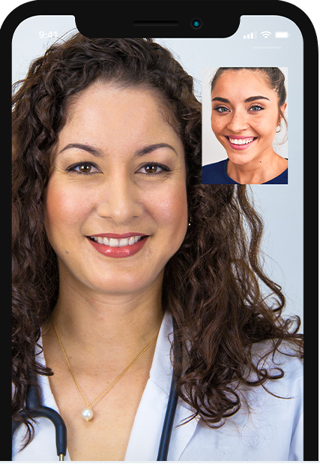

Figure ‑ Video call facility in Plush Care

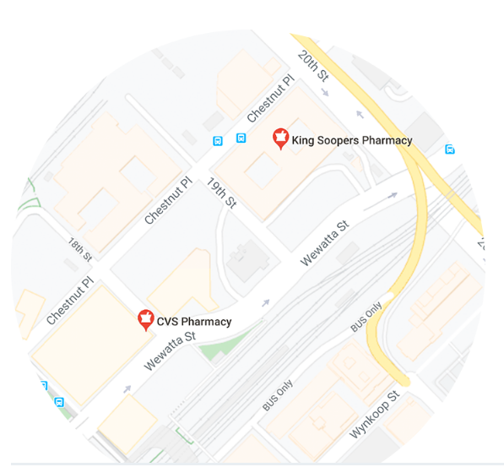

Figure ‑: Sending prescriptions to specified pharmacies.

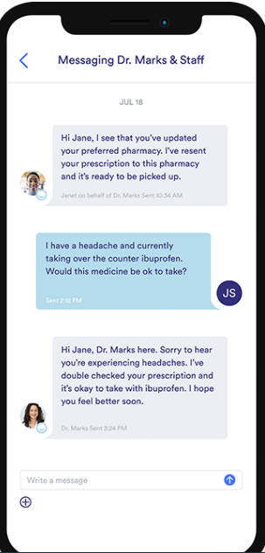

Figure ‑: Chatting with care team

## KRY

KRY is also another mobile app founded in Sweden in 2014, and supports digital healthcare. A patient can log in with his bank ID and has a 15 minutes time to video call the specified doctors. There is a possibility of sharing medical records and also prescriptions are delivered online, and of course payment is online. [6]

This app provides access to doctors, psychologists, and nurses. A patient can book an online appointment for any member of his family who needs to be present during the video call.

When the patient needs a physical examination, he can book for a physical visit to one of KRY healthcare centers.

After check-up, the patient can receive his prescriptions and also his medication while sitting at home. [7]

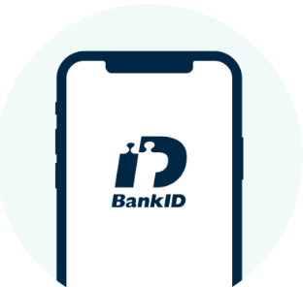

Figure ‑: Login with bank-ID

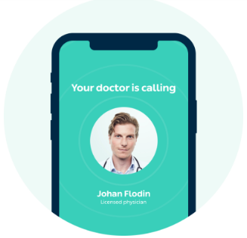

Figure ‑: Video call with your doctor.

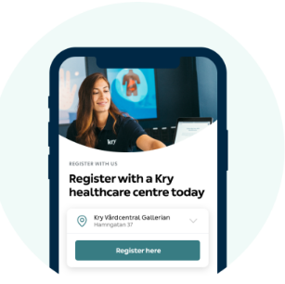

Figure ‑: Reserve a physical visit to the healthcare center.

## Doctor on Demand

It is a mobile healthcare app and website that allows the patient to connect to any doctor with 24/7 availability, and presents a variety of doctors and psychologists to chose from. In addition, it provides the upfront pricing. [8]

The app supports some insurance systems which reduce consultation costs; all the physicians are highly skilled and licensed. The patient needs to provide his medical background before appointing for a video call, he need to provide specific symptoms, the doctor will take this information, analyze it and proceed with the treatment. [9]

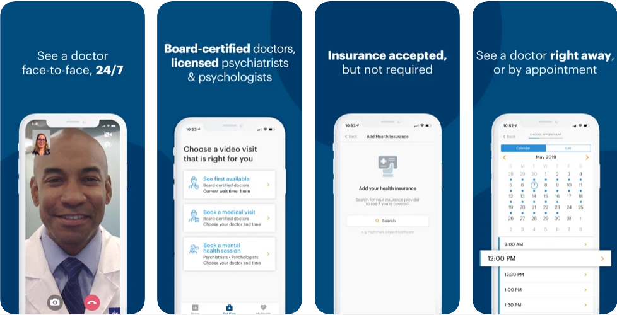

Figure ‑: Doctor on demand features.

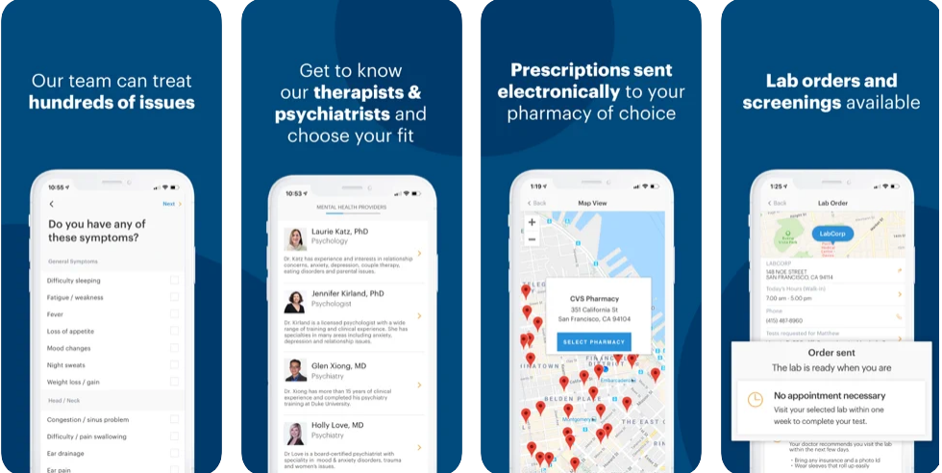

Figure ‑: Additional features.

**Table ‎2‑1: Comparison Table**

|  |  |  |
| --- | --- | --- |
| **Method** | **Advantages** | **Disadvantages** |
|  |  |  |
| PlushCare | Time efficient and wide range of choices. | It is purely virtual and no  Possibility to book for a physical visit. |
| KRY | Time efficient, wide range of choices.  Possibility booking for a physical visit. | Video calls are restricted to 15 minutes and physical visits are restricted to KRY healthcare centers.  Login is allowed only with Bank ID. |
| Doctor on Demand | Supports various insurance systems, and has the most acceptable UI | It is just for non emergency cases that can be treated remotely, no booking for physical visits. |

## Conclusion and Motivation

After describing three similar systems and showing their advantages and disadvantages,

we are intending to design a system that merges the advantages, and gets rid of the disadvantages. So in order to fill the gaps and deficiencies in the above mentioned methods, our app will support a specialty and geographical locality filters for doctors, a possibility and joining an online meeting with a specified doctor, an online reservation service to physically visit a doctor in case of serious symptoms, a variety of easy login methods, a possibility of getting E-prescriptions, a possibility of sharing medical documents, and an ability of accessing variable offers provided by various doctors.

# System Design

## Introduction

This chapter will go through the project's specifications as well as how users will communicate with the mobile app. In addition, some use cases will be addressed in order to demonstrate how the device will behave in each case and how the intended outcome of each case will be delivered.

In addition, the backend architecture and sequential flow of the current mobile application will be discussed.

Furthermore, none technical aspects of the project, financial viability, stakeholders, risks and other considerations are to be listed in details.

## Requirements and Specification Analysis

It's crucial to explain the specifications and use cases that make up a mobile app's foundation so that we can better understand the app's structure and what sets it apart from other similar structures.

Since the back-end of an android application must be developed remotely, a cloud database hosted on one of the Google servers will be used, allowing for lightning-fast queries.

More specifically we will need:

* Android Studio 4.0.0: needed for setting up an Android project and writing code. [10]
* Firebase as cloud database: It is a server, API, and datastore, all written in a very generic manner. [11]

This application has primarily two use case actors: the patient and the doctor. The use case diagrams for each actor, according to the application functions, as well as the actions that each actor may perform, are shown below.

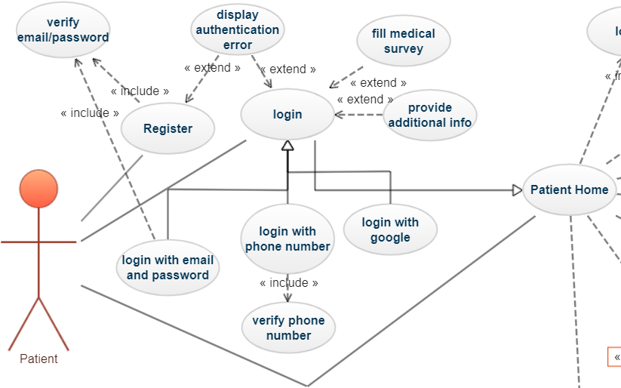

Figure ‑: Patient use case part 1.

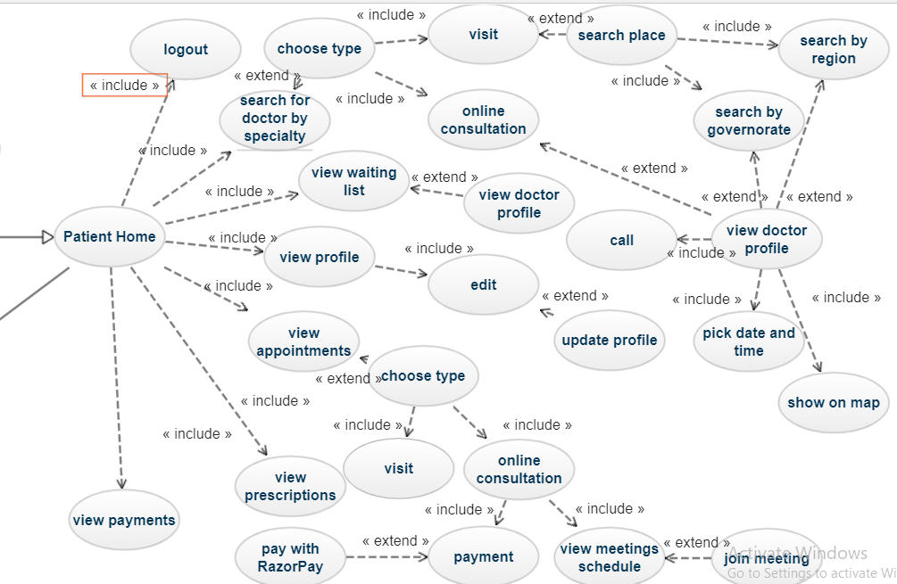

Figure ‑: Patient use case part 2.

Table : Patient use case narrative

|  |  |  |
| --- | --- | --- |
| **Use Case Name:** | Booking Appointments | |
| **Use Case ID:** | 01 | |
| **Primary Actor:** | Patient | |
| **Description:** | This use case depicts a general case in which patients may schedule medical appointments (either in person or by telemedicine). The patient will begin by creating an account and logging in. He or she will upload medical tests and complete a medical questionnaire. The patient can also choose tasks from the home page, which includes: profile, appointments, prescriptions, deals, payments, and, most importantly, searching for a doctor in order to book an appointment. The doctors are sorted by specialties, appointment form, place, and price. | |
| **Events and steps** | **Step 1**: After installing the application on an android mobile phone. the patient creates an account and provides the necessary data about him/herself (name ,email, phone number, address, blood type…), noting that the address is marked on map .  **Step 2:** patient login using email and password (alternatives: phone and Google authentication).  **Step 3:** Thepatient will upload profile image, related medical documents, insurance, and he/she will fill a general medical background survey.  **Step 4:** the patient will choose from home which includes the following sections:  Search for doctors, profile, appointments,  Prescriptions, offers, payments,  and logout. | **Step 4.1:**   * If the patient clicks on search doctors: he/she will be directed to the specialties page to choose from, then he/she must choose the type of appointment (visit or telemedicine. If he/she choose visit then he/she will be able to filter doctors by governorates and regions using a search view, else the patient will choose from doctors online. After choosing a doctor from the final recycler view, a request for an appointment will be done: the patient will click on a “Pick” button, then he/she will be directed to see the schedule of the chosen doctor, and choose an available date and time for him .Then, this appointment date will be saved in the waiting list section waiting for the doctor to accept it.. * If the patient clicks on profile section, he/she will see information about him/herself which was added previously to Firebase Firestore. Also there is an ability to edit this profile and update data in the database. * If the patient clicks on appointment, he/she can see his/her booked appointments. For online consultation, the patient will be able to pay online and also join a meeting with his doctor in the chosen time. For visit consultations, patients will be able to enter the doctor profile and contact him/her. * If the patient clicks on prescriptions, he/she will be able to see the prescription uploaded by the doctor. * If the patient clicks on payments, he/she will be able to see the amount he/she has to pay for the tele_appointment and pay using credit card and other checkout forms. * If the patient clicks on offers, he/she will be able to see special offers announced by doctors. * And finally when the patient click on logout, he/she will be logged out. |
| **Conclusion** | This app has revolutionized how doctors and patients interact by making medical appointment booking simple and enjoyable, as well as improving the accessibility of nearby clinics and relevant medical offers. | |

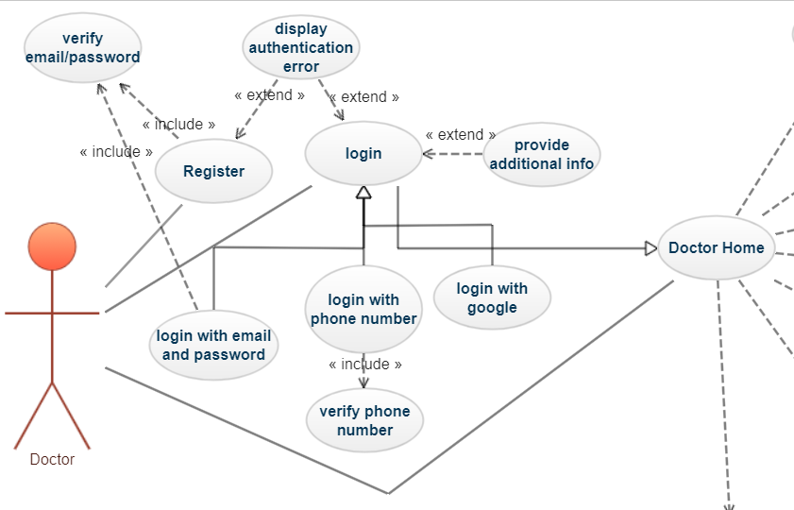

Figure ‑: Doctor use case part 1

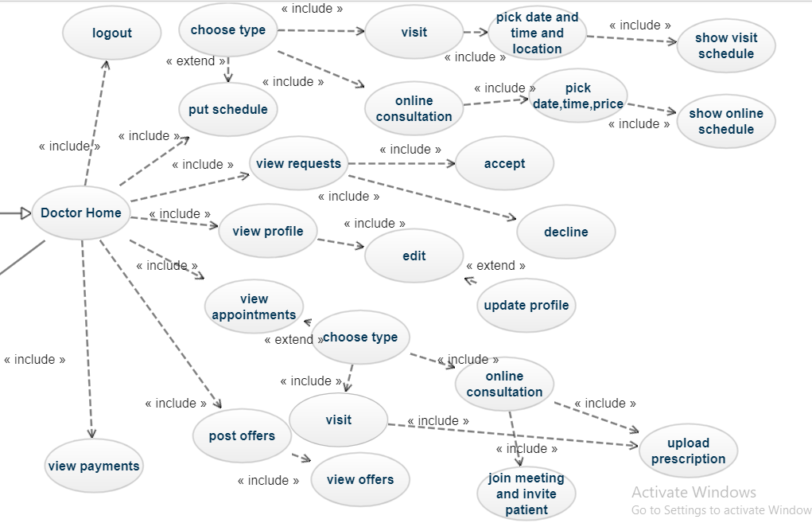

Figure ‑: Patient use case part 2

Table : Doctor use case narrative

|  |  |  |
| --- | --- | --- |
| **Use Case Name:** | Management of reservations, prescriptions and offers | |
| **Use Case ID:** | 02 | |
| **Primary Actor:** | Doctor | |
| **Description:** | This use case depicts a general case in which doctors can create their own working hours schedule (for both visits and online consultation) with respect to the location of clinics or hospitals they work in, receive and manage requests for appointments from patients(either in person or by telemedicine). The doctor will begin by creating an account and logging in. He or she will upload profile picture, syndicate card, certificates pdf file and write a description about him/her. Then, the doctor can also choose tasks from the home page, which includes: profile, requests, appointments, prescriptions, deals, payments, and, most importantly, the calendar section where he/she provide his/her schedules. | |
| **Events and steps** | **Step 1**: after installing the application on an android mobile phone, the patient creates an account and provides the necessary data about him/herself (name ,email, phone number, address, specialty, experience…), noting that the address is marked on map .  **Step 2:** the doctor can login using email and password (alternatives: phone and Google authentication).  **Step 3:** Thedoctor will upload profile image, a syndicate card, certificate file, insurance, and he/she will write a short description of his/her work  **Step 4:** the doctor will choose from home page which includes the following sections:  Calendar or schedule, profile, appointments, requests  Prescriptions, offers, payments, and logout. | **Step 4.1:**   * If the doctor clicks on Calendar: he/she will be directed to the page to choose the schedule type (visit or online consultation.. If he/she choose visit then he/she will be able to specify the date, the time, the location (marked on map the clinic or hospital he/she is working on that date. Else, he/she will specify the date, the time and the price of the online consultation. After all done, the two schedules will be distributed according to the days of the week. Doctors are able to view them later and modify them (add, delete…) * If the doctor clicks on profile section, he/she will see information about him/herself which was added previously to Firebase Firestore. Also there is an ability to edit this profile and update data in the database. * If the patient clicks on appointment, he/she can see his/her accepted appointments with the ability to add these events to his/her own calendar. * After the appointment is done, the doctor can upload a prescription in the patient profile. * If the doctor clicks on requests, he/she will be able to see all the patient requests for appointments and chooses if he/she accepts or decline appointments. Accepted appointments will be added to the appointment section but declined appointments will be available to other patients.. * If the doctor clicks on payments, he/she will be able to see the checkouts by the patients (in the case of online consultations, the doctor can decline the appointment if the payment by the patient was not done). * If the doctor clicks on offers, he/she will be able to announce his/her special medical deals. * And finally when the doctor clicks on logout, he/she will be logged out. |
| **Conclusion** | This app has revolutionized how doctors and patients interact by making medical appointment booking simple and enjoyable, as well as improving the accessibility of nearby clinics and relevant medical offers. | |

Figures below depict activity diagrams showing the movement of control in our application for further illustration. An activity diagram is a diagram that presents the action/response of the system in development and thus clarifies the system's execution mechanism.

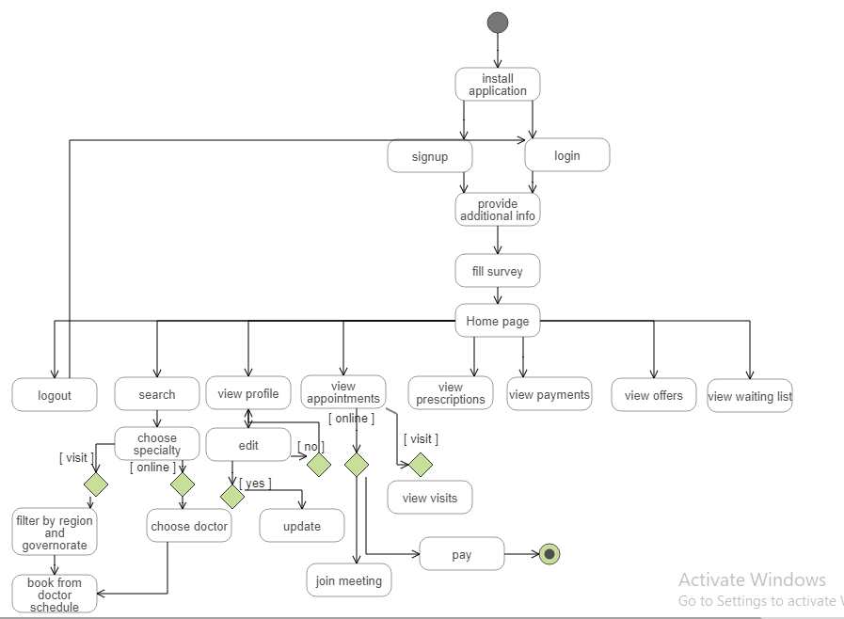

Figure ‑: Patient activity diagram

The above diagram shows the control flow between activities inside the patient’s section of the application.

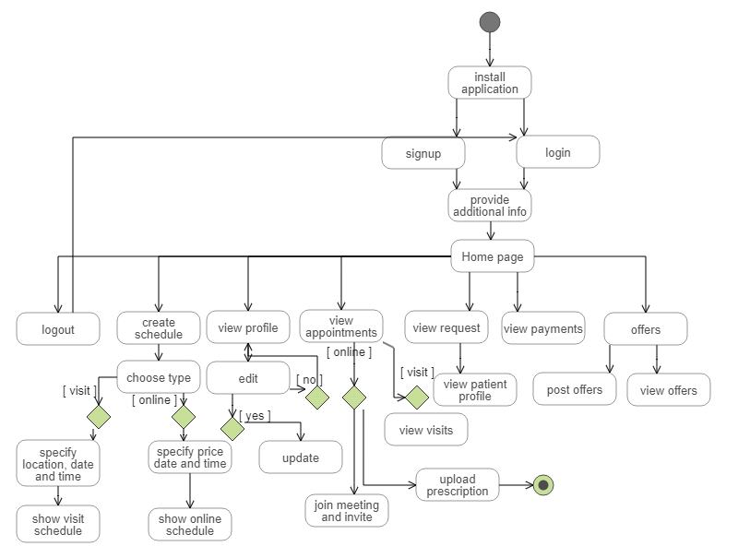

Figure ‑: Doctor activity diagram

The above diagram shows the control flow between activities inside the patient’s section of the application.

## Financial Viability

The developed application needs a backend server. To work properly, these servers cost according to the hardware, the cooling energy, the internet bandwidth….However, as a senior project, this mobile app costs nothing because it depends on free hosting services provided by companies like tools offered by Google (Firebase, special APIs….).

In the long term, it will become costly depending on the number of users because for example, services provided by Firebase are free for a limited quota, so exceeding this limit will have a price. Also, maybe there will be a need to buy a server.

On the other hand, profit is not intended from this app at our level as its goal is limited to reconciling patients and doctors in the best way. However, in order to compensate its future expenses, we can make doctors pay for using the app services once they install it.

## Project Management Aspects

### Stakeholders

The beneficiaries from this project are every patient who wishes to make an appointment with a doctor located within his geographical vicinity, every person who wants to save money and get diagnosed inside governmental dispensaries or benefit from the special offers, every citizen who lives in remote areas or his physical ability does not allow him to reach the doctor and thus he can benefit from the telemedicine.

Moreover, there are doctors who will acquire more patients and share tips and instructions with them.

This program will be under the supervision of the Medical Syndicate to examine the legality of the practices applied within it.

### Scope

Within this mobile application, a special section for doctors will be created that enables them to share their information with patients, especially their schedule. Another one will be created for each doctor in order to check the reserved appointments. Also, there is a page for special offers made by each doctor and a place to share and receive all medical documents.

As for the other section, it is for patients who fill in general medical questions and store the file of answers in their profile. They will be able to choose the doctor according to the specialty and filter the doctors according to the geographical location.

In addition to that, there will be an ability to book an online medical appointment and also share check-ups with doctors.

Communication between the two parties will take place via calls and also in the case of an online consultation, the doctor and patient can meet in an online room.

This app will be done with fake doctor’s ID and a substitute for the syndicate card for doctor’s identity verification.

Also for the payment, a payment method will be implemented but the checkout will not take place.

Another thing that will not be done due to the limit time is an app that represents a platform between doctors and pharmacist to control the medicaments sales and to prevent using one prescription to buy the same medicament more than one time from different pharmacies.

### Risks

There is a risk if the information and the medical documents uploaded by a specific patient were viewed by someone else. This means that another person will know the patient links with doctors and all of his health issues, which is unethical if the patient doesn’t want to provide this information to public. Therefore, security and privacy must be fully respected.

### Schedule and Milestones

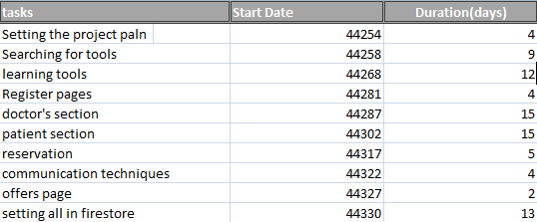

Figure ‑: Schedule of the tasks to be completed.

Figure ‑: 3D bar chart of the tasks schedule.

This schedule includes for sure the completion of the various sections of the report, and the remaining time will be used to fix errors if any.

## Ethical and Social Considerations

This app should be used with responsibility, patients and doctors should provide correct information about themselves. Also, patients must respect their appointment times, pay for their online consultations. At the same time, doctors must follow the schedules they provide and refund patients if errors occur in case of online consultations.

## Environmental and Sustainability Considerations

Our project is not related to environment, its goal is to be a link between patients and doctors all around Lebanon and maybe wider, also provide special services for both sides.

## System Architecture

Mobile application design is a compilation of methods and patterns that must be used to create a fully integrated mobile app that adheres to industry guidelines and vendor specifications. [12]

As a result, establishing consistent and well-thought-out framework architecture for our application system is critical as a basis for the implementation and testing of a dependable mobile booking medical appointment application.

The design of mobile application architecture usually consists of many layers, including: [12]

* **UI:** This is the graphical interface from which users and stakeholders can communicate and issue commands to the program. Any step taken by this app is an input that must be evaluated and treated in order to accomplish the user's desired outcome.
* **Backend dataflow:** Easy visual communications are converted into automated instructions, which are then relayed to the backend server for execution. In the other direction, all database findings are made by this engine and reverse-translated into content that the users can understand visually.
* **Database:** Where all data relating to the application is saved, analyzed, and archived. Appointment requests, medical deals listings, user accounts, user profiles, medications, plans, patient surveys, and payments will all be part of the info.

The design consists of 2 sections: patient’s section and doctor’s section. Both are

Required to create accounts and login. For both users, login could be done by email/password, phone number or Google authentication. Then, the patient is directed to provide additional info about himself/herself, For the doctor, he/she must upload profile picture, syndicate card, a pdf file with his/her certificates and also he/she must write a description about him/herself. After this, both sides are directed to their home pages.

The patient home page includes 7 tasks: search for a doctor-profile, appointments, prescriptions, offers, payments and logout. Search for a doctor will direct the patient to an activity that allows him/her to filter doctors by their specialties, then type of consultation. If visit, filtering by region and governorate is done, else a doctor for an online consultation is chosen . after choosing, the patient will be able to book an appointment and this appointment will be waiting and requested to the doctor in order to be accepted or declined.

When the patient clicks on the appointment section, he/she will see an activity showing all his/he accepted appointments, with the ability to delete appointments. The patient needs to pay for online appointments as well as joining an online meeting at the specified time.

When the patient clicks on the profile section, he/she will be able to view all his/her personal info previously uploaded to the firebase. If he/ she click on “edit profile” button, he/ she will be able to modify his/her info and update them on Firestore.

When a patient clicks on the prescriptions sections, he she will be able to see prescriptions upload it by the doctor.

When the patient clicks on the payment section, he/she will be able to see his/her paid transactions.

Clicking on the offers sections will let the patient see the offers provided by doctors.

Clicking on the logout button will let the patient go back to the login activity to login again.

For the doctor, the home activity also contains 7 sections: Schedule or calendar, profile, requests, appointments, payments, offers and logout. For the profile and the logout sections, the process here is similar to the patient interaction with these 2 sections.

The calendar activity makes the doctor able to specify dates, times, prices, locations for his/her online and visit consultations schedule.

If the doctor clicks on requests section, he/she can see patient’s requests for appointments; he/she can either accept an appointment or decline it.

If the doctor clicks on appointments section, he will see the accepted appointments, and he/she can add these events to his/her own calendar.

If the doctor clicks on offers section he will be able to post all his desirable offers.

The figure below will show 3-tier architecture of our application.

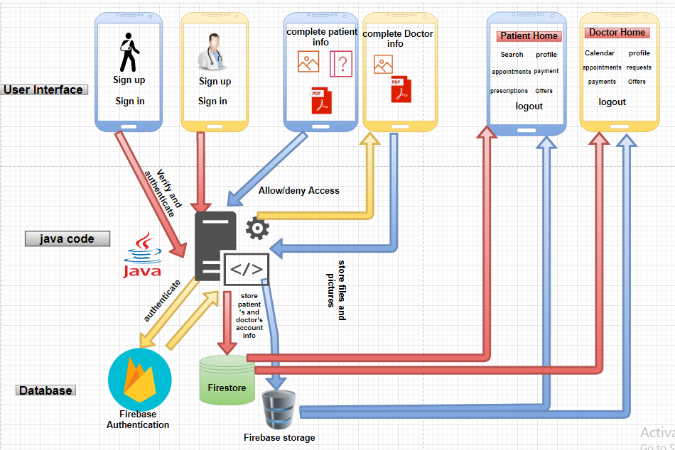

Figure ‑: 3-tier architecture diagram

## Relevant Standards

Wi-Fi: wireless fidelity (standard IEEE 802.11) or cellular networks for internet connectivity.

## Class Diagrams

The objective of a class diagram is to represent an application's static view. The only diagrams that can be directly transferred to object-oriented languages are class diagrams.

The class diagram's goal may be described as follows: [13]

* Analysis and design of an application's static view.
* Describe a system's methods and duties

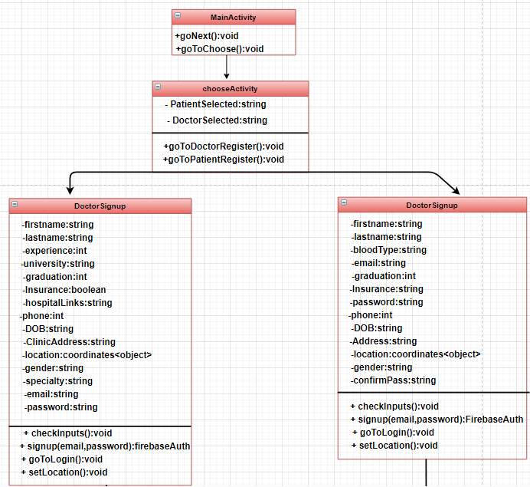

Figure ‑: Class diagram part 1

Figure ‎3‑10 shows different variables that constitute both doctor and patient profiles, along with the different methods provided to check these inputs, authenticate sign up/in methods…

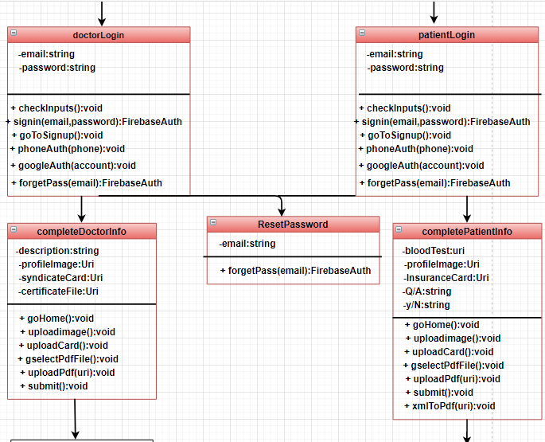

Figure ‑: Class diagram part 2

Figure ‎3‑11 shows the next step after signing up/in; both patient and doctor must provide additional information about themselves. Methods related to file and image uploads, updating database… are listed.

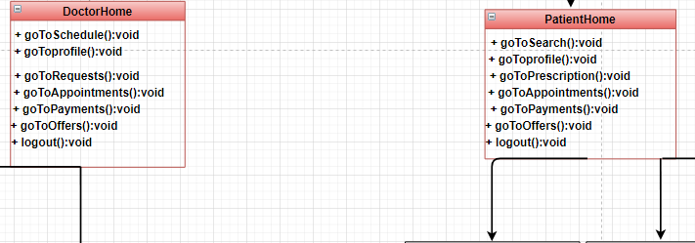

Figure ‑: Class diagram part 3

Figure ‎3‑12 presents what does the home page of the doctor and the patient contains.

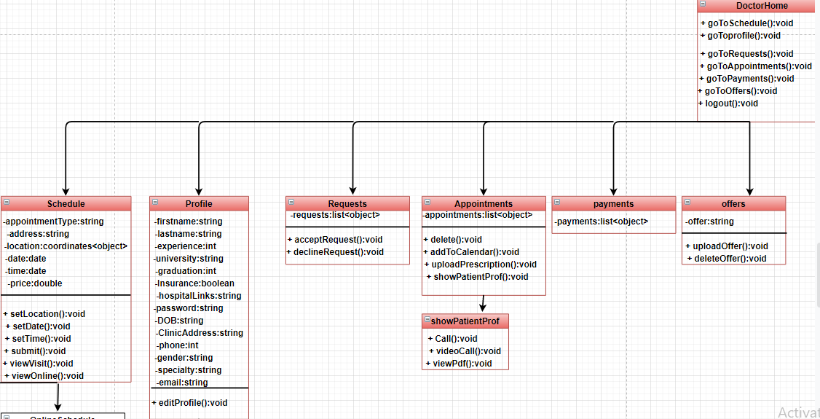

Figure ‑: Class diagram part 4

Figure ‎3‑13 details the content of the activities sourced by the home page of the doctor, along with actions that each activity provides.

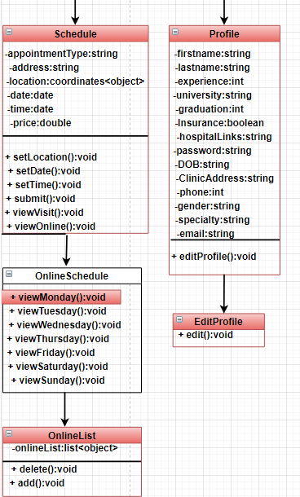

Figure ‑: Class diagram part 5

Figure ‎3‑14 presents in details what does exist in the schedule and the profile activities of a doctor.

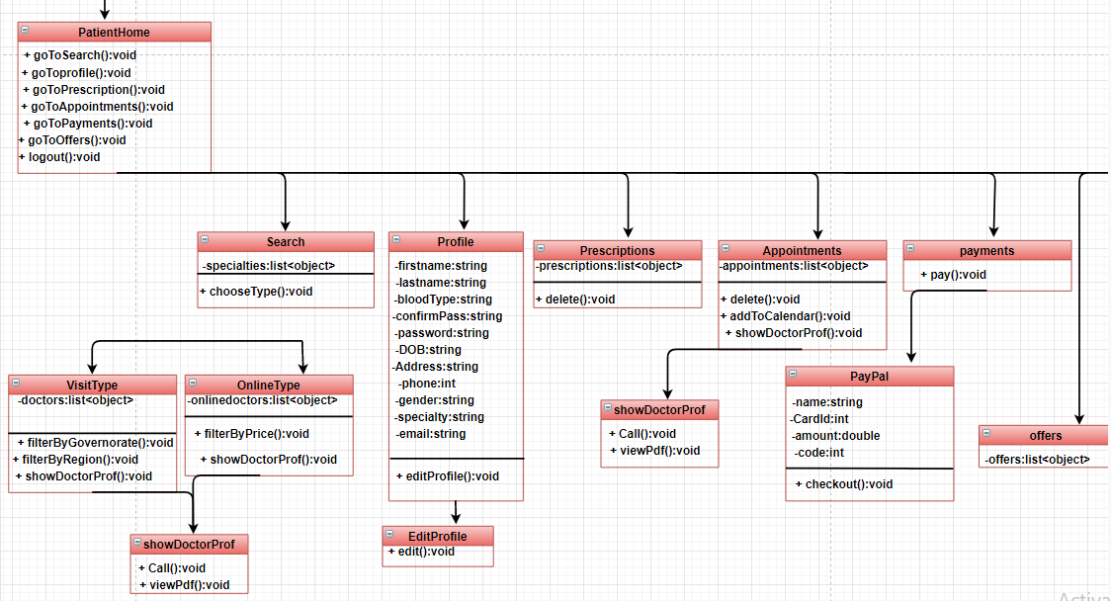

Figure ‑: Class diagram part 6

Figure ‎3‑15 shows the content of the patient’s home page, along with the actions provided by each activity inside it.

## Sequence Diagrams

The UML Sequence Diagrams are interaction diagrams that show how processes are performed. They document the interaction of items in the context of a collaborative effort. Sequence Diagrams are time focused, and they graphically express the sequence of the interaction by utilizing the vertical axis of the diagram to indicate time, what messages are conveyed, and when. [14]

Below are the different parts of the doctor sequence diagram:

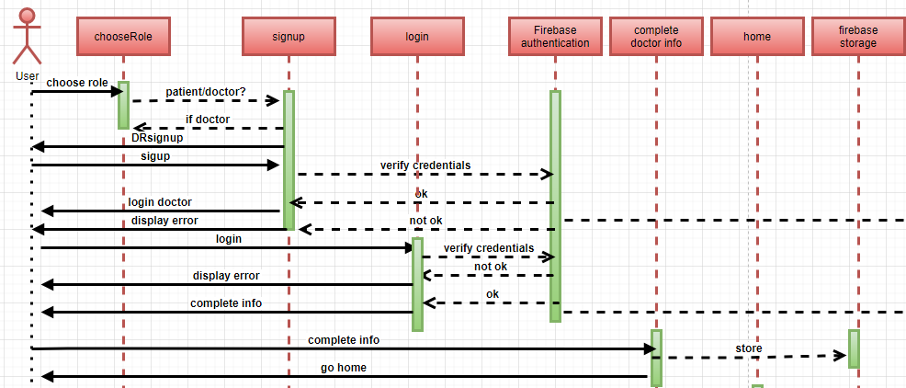

Figure ‑: Doctor sequence diagram part 1

Figure ‎3‑16 shows how the doctor interacts with different activities starting after the installation of the application, reaching the doctor’s home page, passing by different stages : signing up/in(with parallel authentication procedure in the backend), providing additional info..

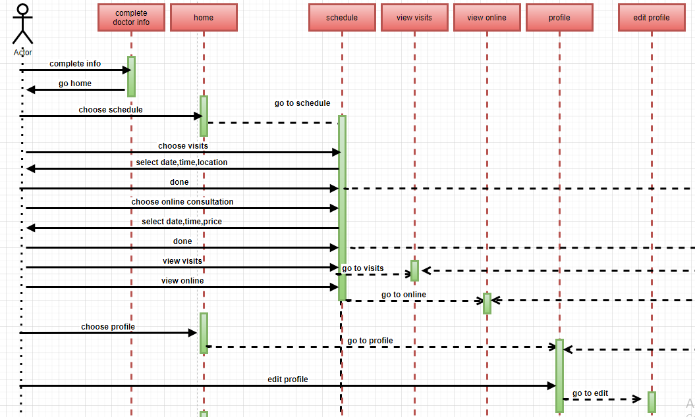

Figure ‑: Doctor sequence diagram part 2

Figure ‎3‑17 completes the path of figure 24 and lists the different actions that can the doctor do after reaching the home page like: putting schedule, viewing this schedule with its different types, reaching profile and editing it.

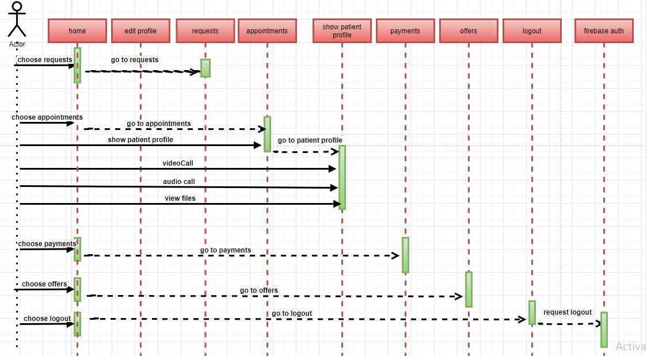

Figure ‑: Doctor sequence diagram part 3

This figure is the final part of the doctor’s sequence diagram, shows the interaction between the doctor and the left activities including managing requests, appointments, communicating with the patient, providing offers and finally logging out.

Below are the different parts of the patient sequence diagram:

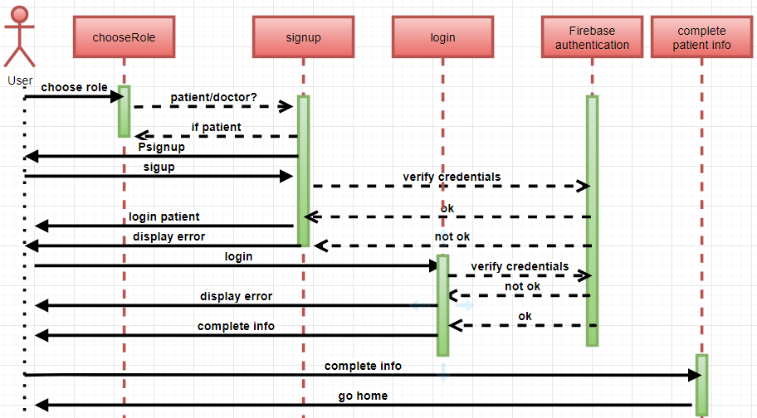

Figure ‑: Patient sequence diagram part 1

Figure ‎3‑19 shows how the patient interacts with different activities starting after the installation of the application, the activity where he/she provides additional info..

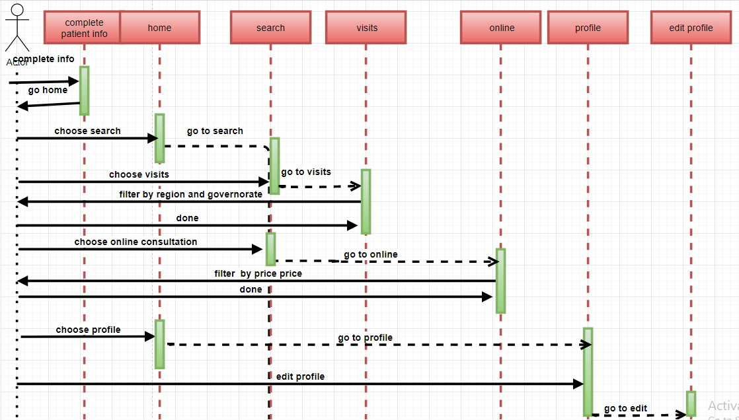

Figure ‑: Patient sequence diagram part 2

Figure ‎3‑20 completes the path of figure 27 and lists the different actions that can the patient do after reaching the home page like: searching for doctors, viewing and picking appointments from their schedules through visit/online activities schedule, reaching profile and editing it.

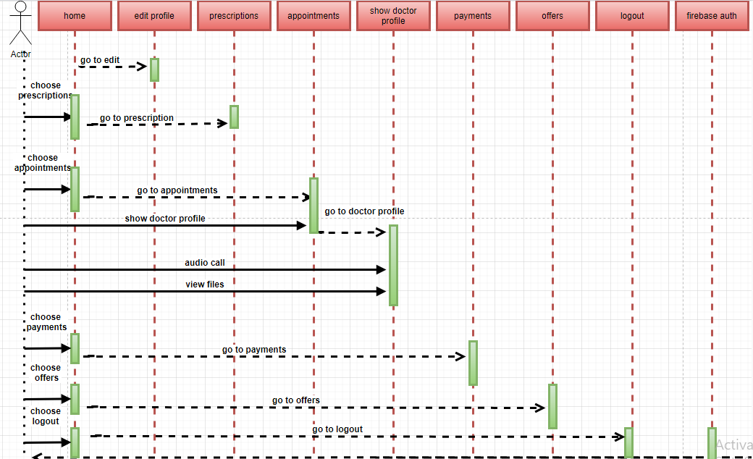

Figure ‑: Patient sequence diagram part 3

This figure is the final part of the patient’s sequence diagram, shows the interaction between the doctor and the left activities including viewing appointments, payments, communicating with doctors, accessing their offers and finally logging out.

Note that info entered or viewed by the user(doctor or patient) are uploaded and retrieved from Firebase storage (pictures, files) and Firebase Firestore (personal info, schedules and their details, offers, payments…)

## State Diagrams

A state diagram is made up of different states, transitions, events, and activities. State diagrams are used to depict the dynamic picture of a system. They are particularly useful for simulating the behavior of an interface, class, or collaboration. State diagrams emphasize an object's event-ordered behavior, which is very useful for describing reactive systems. [15]

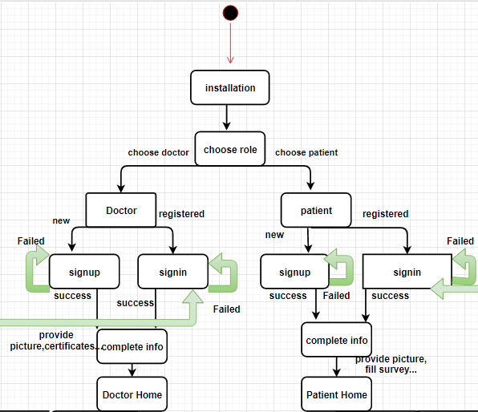

Figure ‑: State diagram part 1

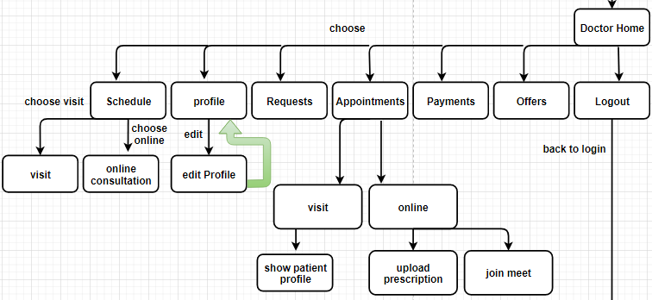

Figure ‑: State diagram part 2

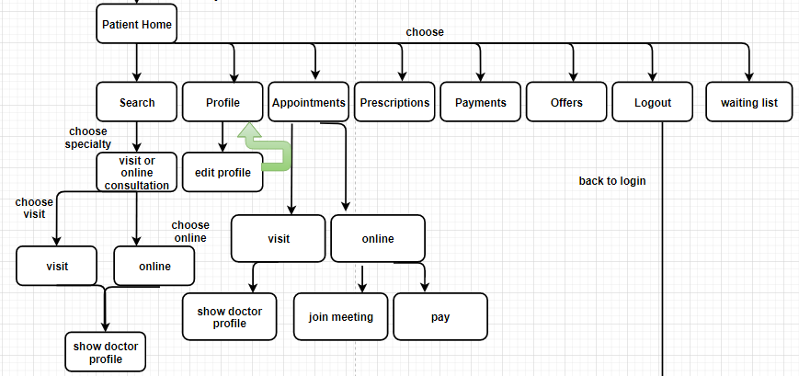

Figure ‑: State diagram part 3

## Conclusion

Finally, a strong system is established on the foundation of a rigorous and well-thought-out design process. A creative mobile application is the one that delivers functionalities as well as a pleasant user experience.

In brief, our application, with its organized and well interacting elements and entities offers the patient the best booking medical appointments experience, also it shows the doctor the best way to attract patients and communicate with them.

# Implementation/Simulation and Testing

## Introduction

This project has taken a lot of steps in its implementation, simulation and testing in order to complete it. Throughout this Chapter, these steps are presented and carefully discussed. This chapter will also show how the backend and front components of this application are put in place so that the final MB-Care + application is eventually developed.

## Implementation Tools

For the creation and testing of MB-Care + application, the implementation tools are mentioned previously and will be detailed as following:

* Android Studio 4.0.0: This IDE is Google Android's official framework for developing Android-based apps, and it's needed for setting up an Android project and writing code. [10]
* Firebase as cloud database: is a Google Cloud Technology-based Backend-as-a-Service (BaaS) that has evolved into a next-generation software development platform. It is a server, API, and datastore, all written in a very generic manner. [11]

It's worth noting that Firebase was chosen over MySQL database in this project. This decision was taken based on a number of factors, which are described below: [16]

* Firebase is a NoSQL database (a real-time document store) that stores and syncs data in real-time; However, MySQL is an open-source relational database management framework based on the domain-specific language SQL.
* Firebase excels at handling large data sets, while MySQL is a decent option for more complex data.
* On the website G2, Firebase has a 4.5/5 customer review rating. MySQL has a lower customer satisfaction rating (4.4).

As programming language: JAVA and XML (for application programming interface are used).

For more details about the back-end, we are using:

* Cloud Database from Firebase
* Cloud Storage from Firebase
* Google Maps API from (Google Cloud)
* Jitsi API
* Razorpay API
* Authentication server hosted on (Google Cloud)

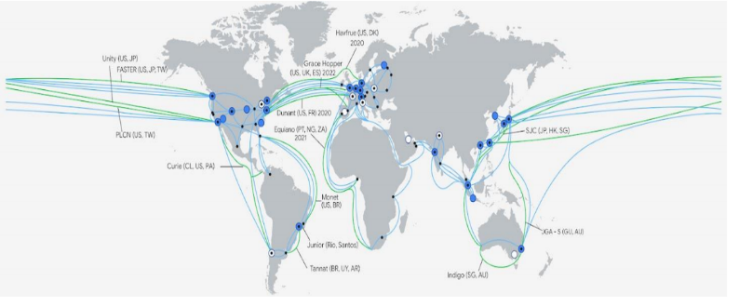

Figure ‑: Google cloud data centers

Not to forget that several libraries and frameworks were used to accomplish principle task such as: payment and online meetings.

For online meetings, an API called “Jitsi” is used. Jitsi is an open source package which allows you to design and deploy safe solutions for video conferencing effortlessly. Jitsi is mostly made up of Jitsi Videobridge and Jitsi Meet, which allow you to have conferences over the internet, but additional community projects provide extra characteristics like as audio, dial-in, recording and simulcast. [17]

For payment, an API called “Razorpay” is used; Razorpay is the supplier of an online payment gateway that allows small companies to commence collecting online payments in an economical and safe method. Its platform provides developer-friendly APIs and enterprise integration for market management, automation of NEFT/RTGS/IMPS banking transfers, recurrent payments collection, and shared customer accounts. [18]

## Implementation Summary

As mentioned previously, this application is developed using Android Studio 4.0 and Firebase as backend, interaction between these two components is needed to accomplish mot of the actions provided by this project.

The main tool to retrieve data from Firebase Firestore and display to the user is: the adapter mainly “FirestoreRecyclerAdapter”. An adapter is used to link the data to the application layout, adapters. Without adapters, the layout would not be able to get the required data for the users of the app. Figure below illustrates a “MB-Care +” adapters that each of them is associated to a particular layout.



Figure ‑: MB_Care + adapters.

Every adapter needs a model class that specifies what to be set inside the view elements of the design associated to the adapter. The models generated for MB_Care+ are used to manage and populate a certain set of data collected from Firebase Firestore in order to be shown to the user.

Below are shown all the application model classes:



Figure ‑: Model classes

Now, all what is left are the activities where all actions took places. Activities constituting this application are presented below along with their layouts:

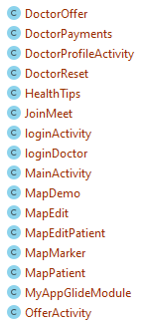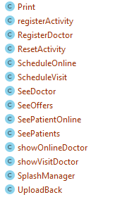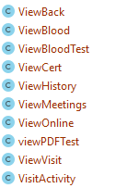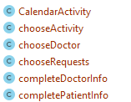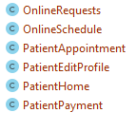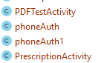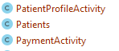



Figure ‑: MB_Care+ activities

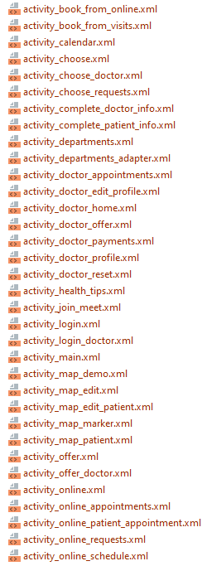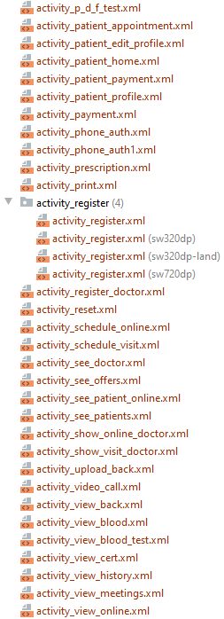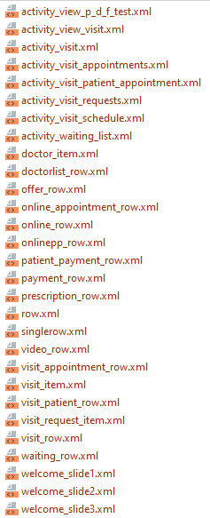

Figure ‑: XML layouts

Now, let’s move on to go deeply in details in every activity. The application starts with a view pager like below:

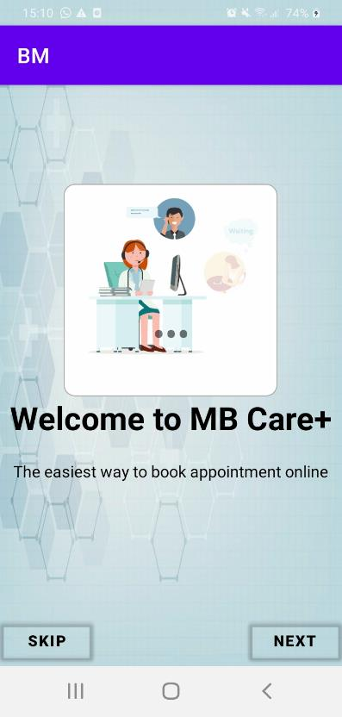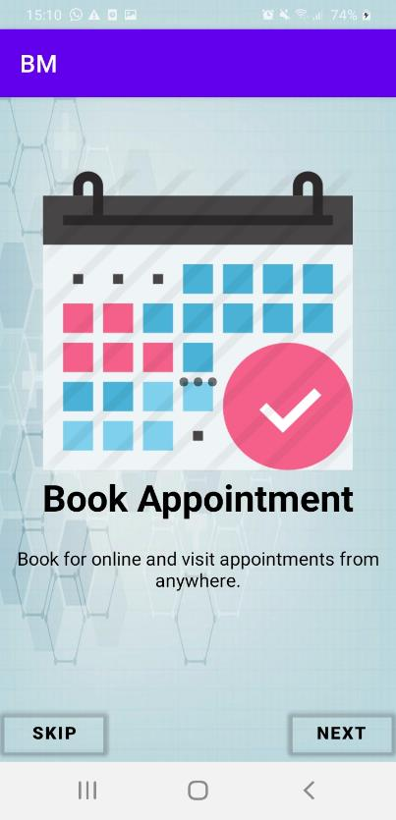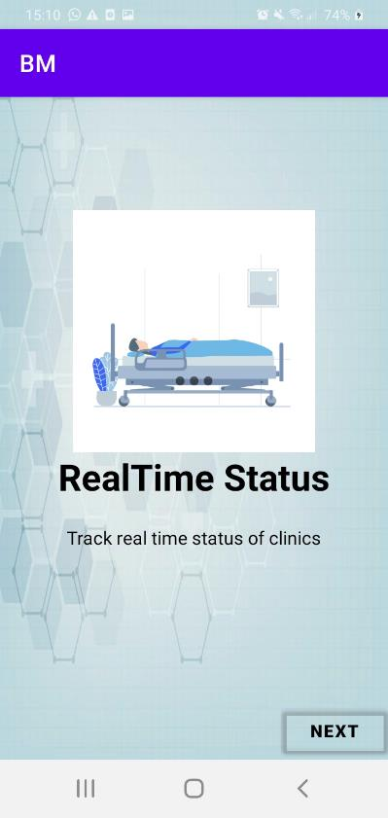

Figure ‑: View pager design

The user will just swipe between these activities after launching the app, and this will just give him/her hints about the characteristics of this application.

In order to be able to use this application, both the doctor and the patient should have a registered account on it.

Before this, the user must indicate his role (doctor or patient) in the activity below:

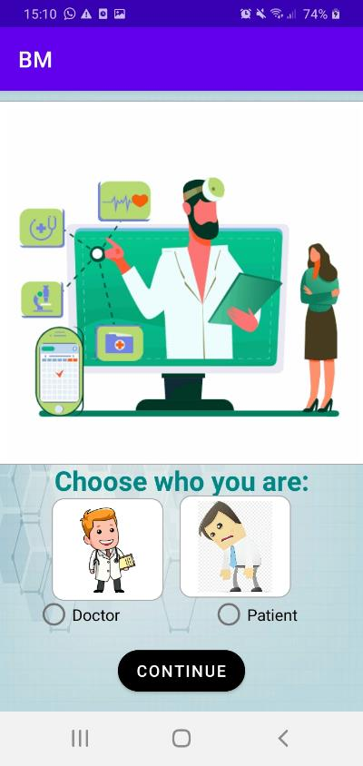

Figure ‑: Role choice

In the below figure, the user must specify if he is a doctor or a patient. Choosing “Doctor will direct him/her to the doctor’s login page, else the user will be directed to the doctor home page.

Let’s see an example:

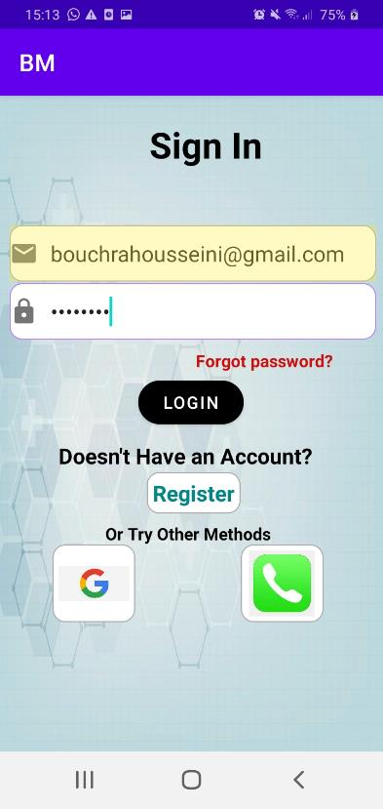

Figure ‑: Login activity

The figure above shows the login activity, it is the same for both doctors and patients. It contains 3 login methods:

1. **Email/password authentication:** the patient or the doctor is asked to enter a valid email address and a password. After clicking on “login” button, the application will connect to Firebase with queries if there are any linked account to this email address.

Note that the patient cannot login with an email address used by a doctor to insure that all the required info is filled by each one (in the sign up activity).

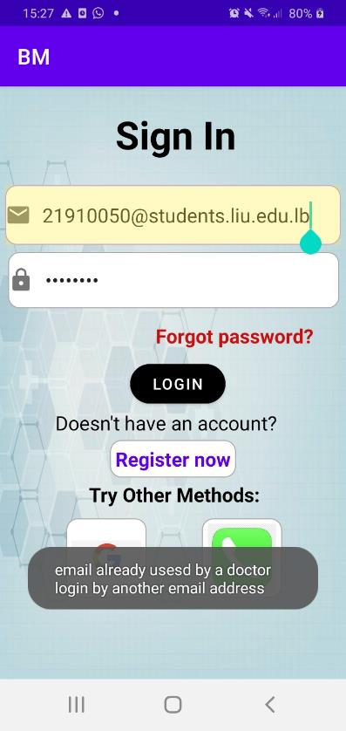

Figure ‑: Access denied

This activity shows a toast claiming that the email address used by the patient trying to login is used by another doctor, so he/she should sign up and provide all the needed info.

1. **Phone number authentication:** the easiest and simplest authentication method, the doctor or the patient should enter a valid phone number and wait for a code to be received as an SMS message and it can be auto filled like below.

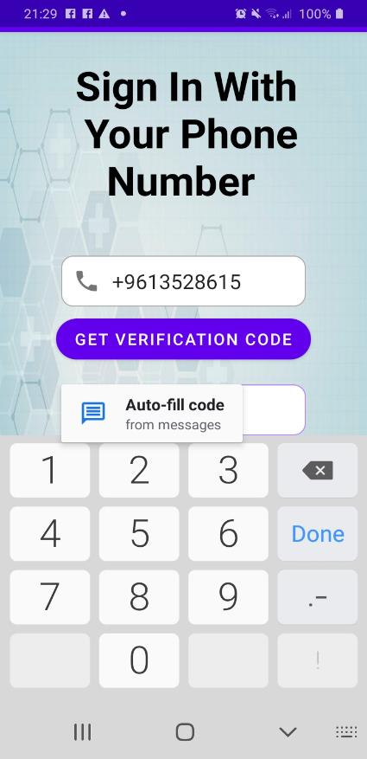 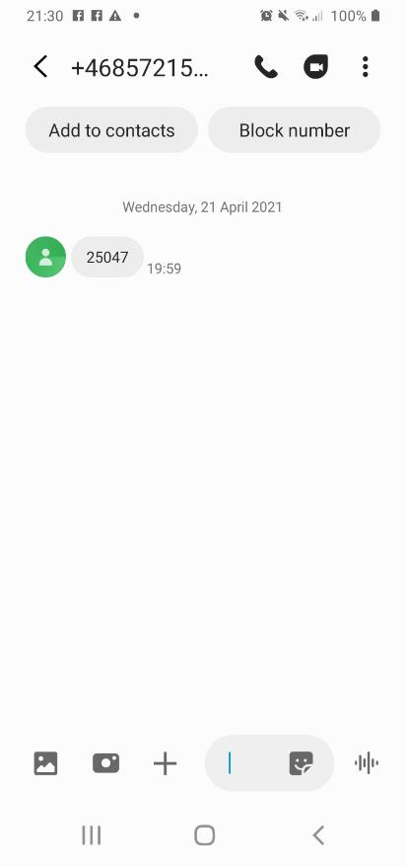

Figure ‑: Phone authentication

1. **Google authentication:** when the doctor or the patient clicks on the Google icon, the user must choose a Google account ,at this moment, the application will retrieve the sign in token related to the selected account. Below is an example about what we have just mentioned:

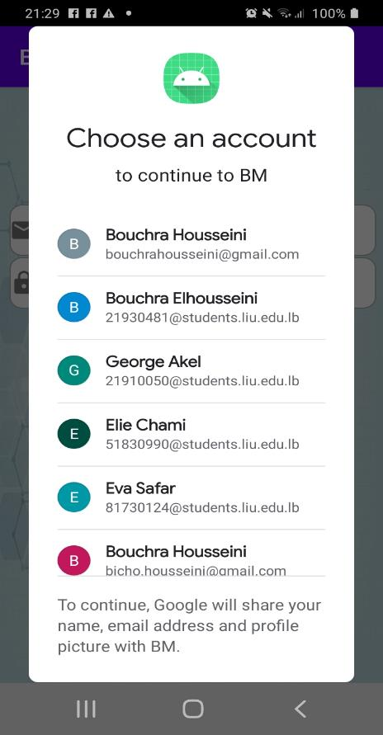

Figure ‑: Google sign in

If the user forgets its password, he/she can reset it by clicking on the “forgot password” text view. He/she will be directed to the “Reset activity shown below:

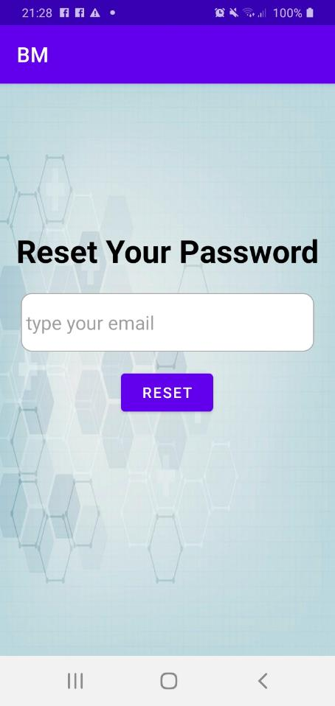

Figure ‑: Reset password activity

The user is required to enter the email he signed in with and the clicks on reset button, an email is sent to him/her where he/she can create a new password and login again with it.

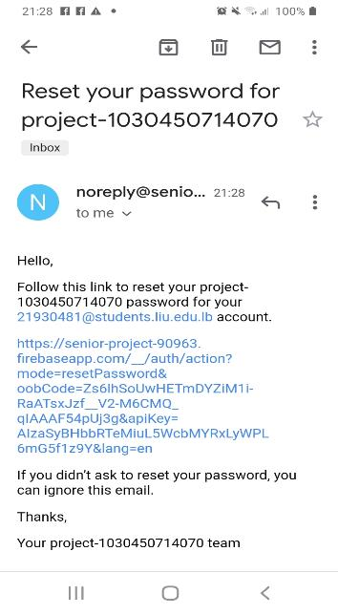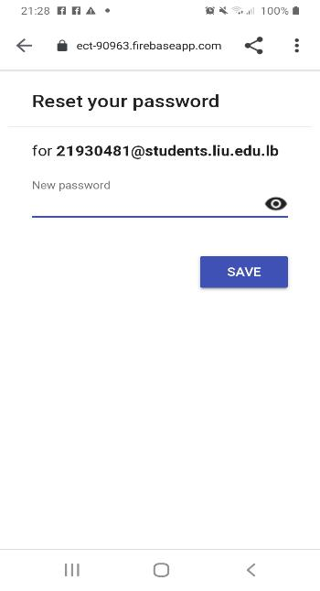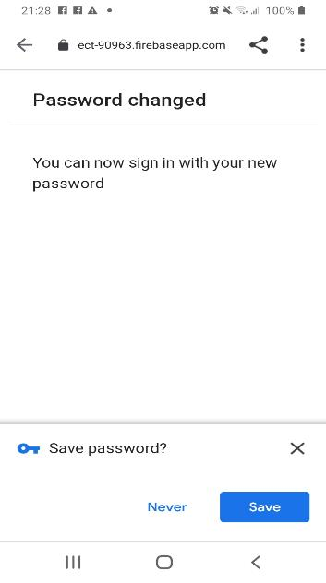

Figure ‑: Password is reset

Not to forget that the same processes apply to the patient login.

For new users, a signup process with an email and a password must be done with a firebase authentication. When the signup activity is launched after clicking on the register button inside the login activity, the doctor is asked to provide some information about him/her. The figures below show the signup activity of a doctor.

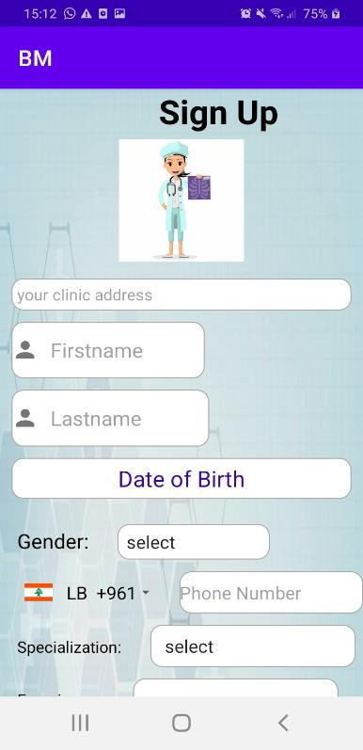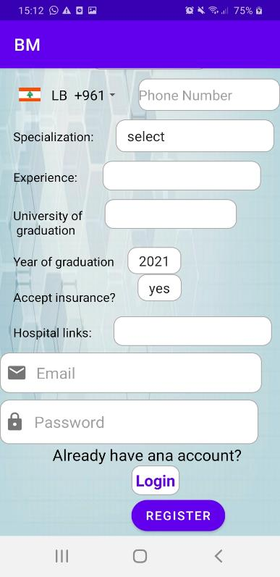

Figure ‑: Doctor signup activity

In this activity, the doctor is asked first to locate his clinic, clicking on the text view will open an activity containing a Google Map fragment, locating the address of the clinic on the map is done by clicking on its specific place on it, a marker will be set at the place of the click containing the longitude and the latitude of this chosen location, then these coordinates are then translated to an address name using a “geocoder”. After choosing the location of the clinic on map, the doctor will set it to the text view by pressing a button “set location” which will redirect the doctor to the signup page and sets the text of the text view to the address name.

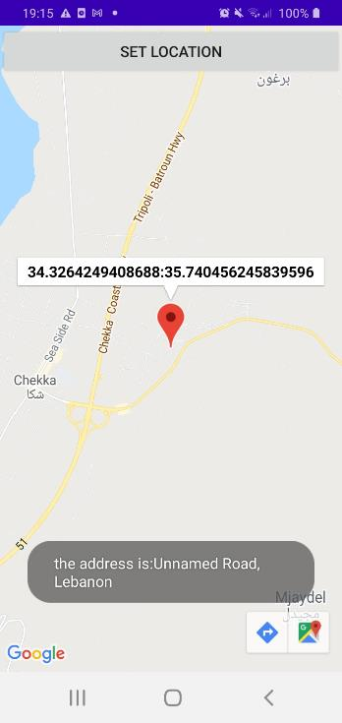

Figure ‑: Specifying clinic location

After that, and as presented in Figure ‎4‑11, the doctor must provide his full name, his date of birth after clicking on the “date of birth” text view using a date picker like below:

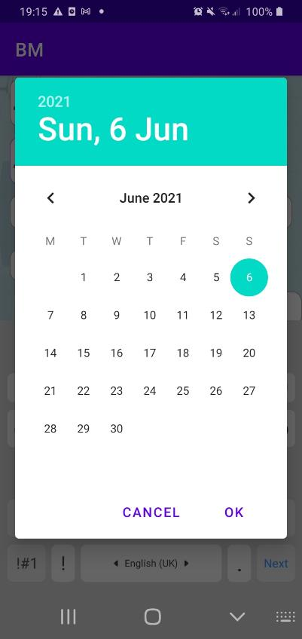

Figure ‑: Set date of birth

Also, he/she needs to provide his/her gender, phone number (country code is specified using a country code picker )like below:

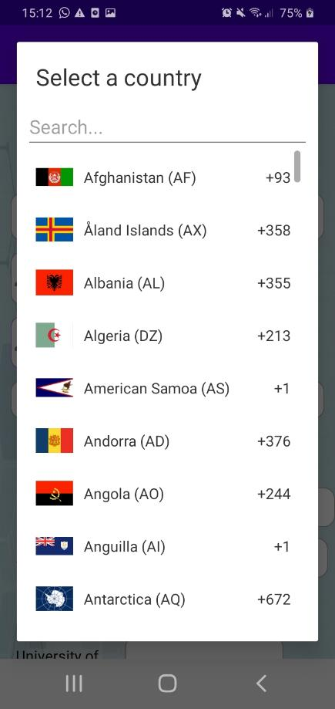

Figure ‑: Choose country code

And then, a doctor should choose his specialty from a spinner containing almost all medical departments:

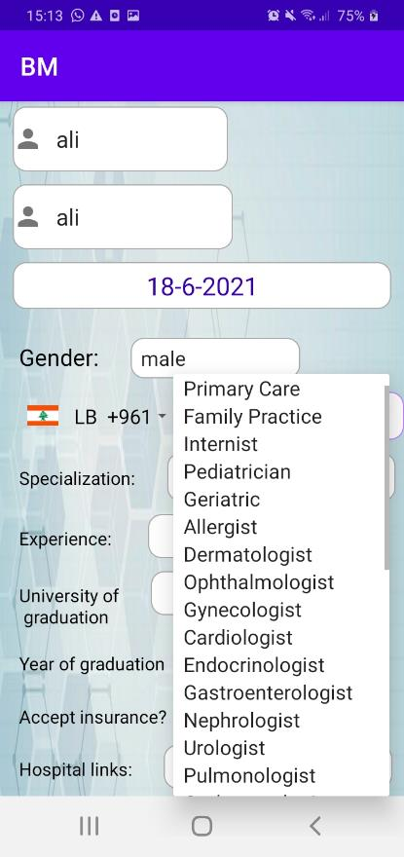

Figure ‑: Choose department

Then, he/she must specify his/her years of experience, university of graduation, year of graduation, if he/she accepts insurance or not, his/her hospital links, a valid email and a password. Clicking on the register button will send a request to Firebase in order to validate this email and password also after the click on this button all the provided information will be stored in Firebase Firestore under the collection “Doctors” and document “Profile “doctor email””. Clicking on the login text view will redirect the doctor to the login activity.

For a patient same procedure applies, but the patient must, for sure provide some different information like his location, full name, date of birth, gender, blood type, phone number, a valid email, password and then, he/she must confirm this password.

After registering all the entered data will be stored in Firebase Firestore under the collection “Patients”, document “Profile “patient email””.

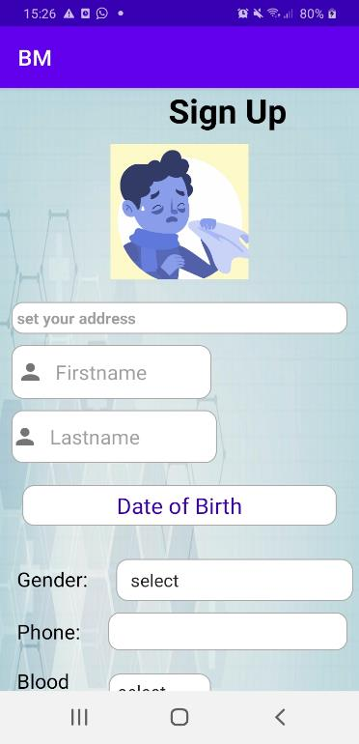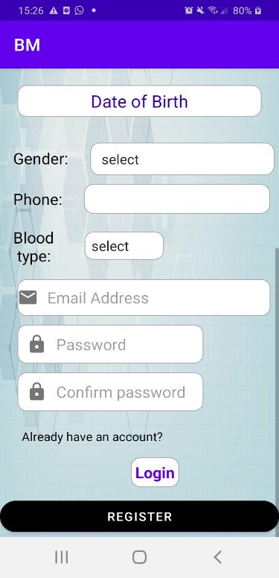

Figure ‑: Patient signup activity

Now, after finishing the signup/sign in processes for both doctor and patient, let’s move to other activities:

* **For doctors:**

After logging in, the doctor will be directed to an activity where he/she needs to provide additional information like: profile image, syndicate card, a certificates file, and also a brief description about his/her medical experience.

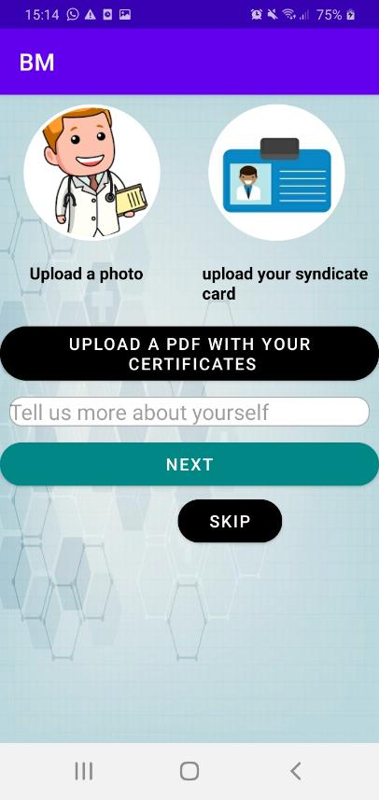

Figure ‑: Doctor's additional info

In this activity, when the doctor clicks on the image view associated with “upload a photo”, he/she will be directed to choose an image from the internal storage like below:

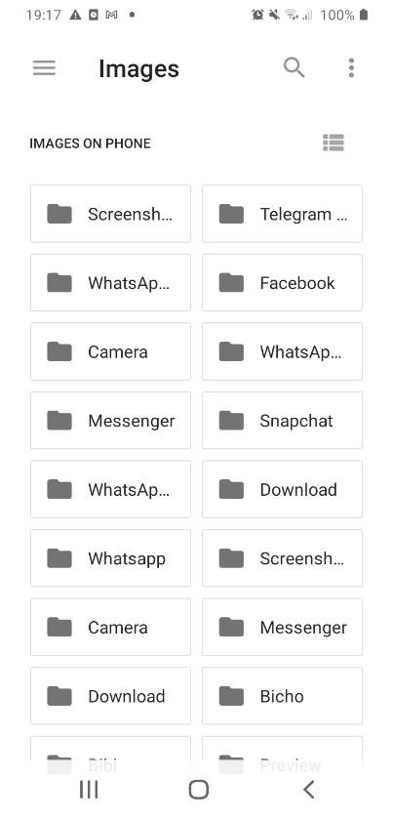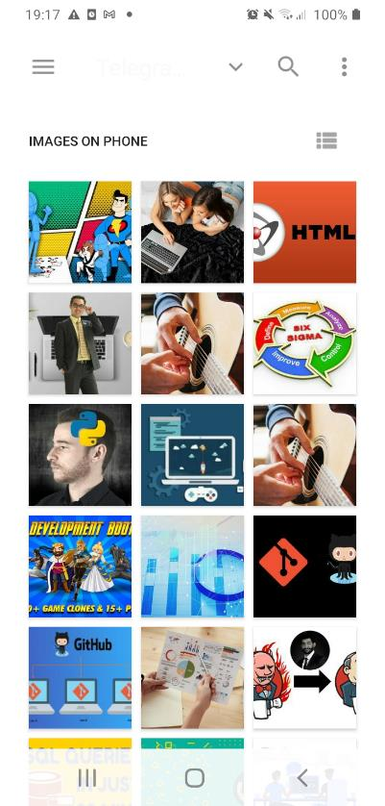

Figure ‑: Choose an image from internal storage

After picking an image this image will be set to the image view, and at the same time it will be added to Firebase Storage, its url will be stored in Firebase Firestore under the profile document inside the “Doctors” collection.

When the doctor clicks on the “upload a pdf with your certificates” button, same thing happens as when uploading an image but this time the doctor can only pick a pdf file from the internal storage.

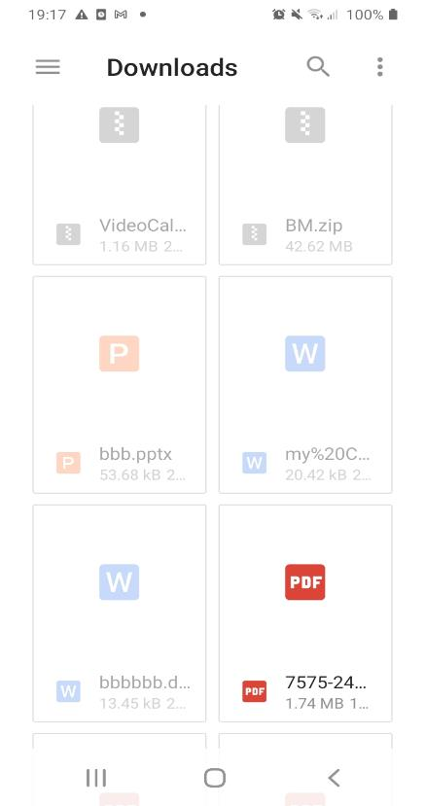

Figure ‑: Uploading pdf

Clicking the next button will add the uploaded files and images to firebase storage, and their urls with the description to Firebase Firestore under the same document as above, then the doctor will be directed to the home page.

Clicking on the skip button will simply direct the doctor to the home page and skip every upload to the database.

Now that we are reaching the doctor’s home page which looks like below:

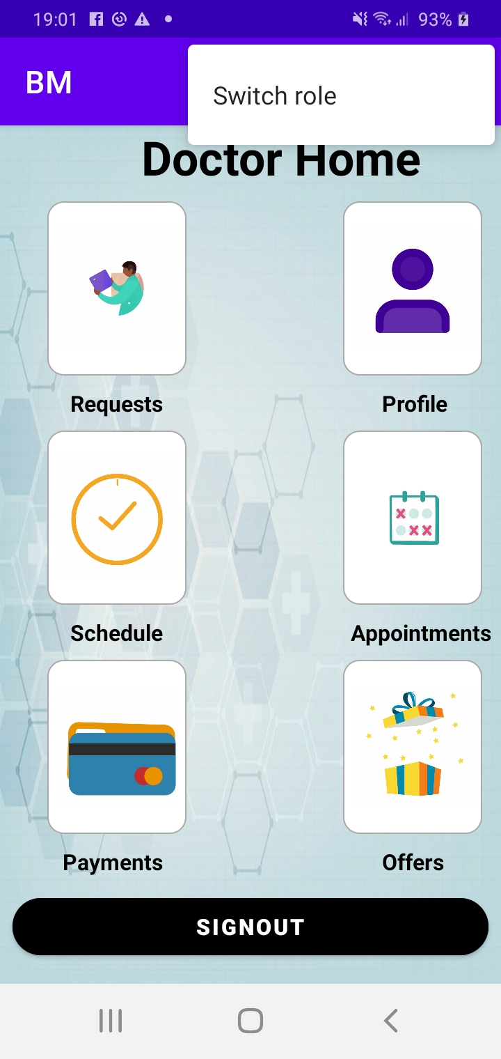

Figure ‑: Doctor's home page

As we can see, the doctor can perform multiple tasks in this activity:

Clicking on the requests image, will direct the doctor to the requests activity below:

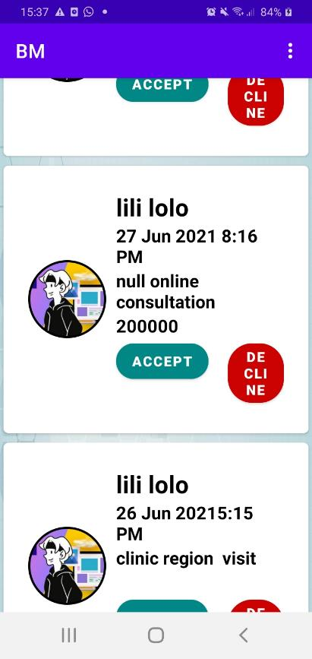

Figure ‑: Doctor's request activity

In this activity, we are using a Firestore recycler view in order to display the patient’s requests for the medical appointments from the database (both visit and online consultations). Each row in the recycler view will display the profile image of the patient, along with his/her full name, date and time chosen, the address of the consultation if it’s of “visit” type, the price of the consultation if it’s of “online type, and 2 buttons.

Clicking on the accept button means that the doctors accepts the request of the patient, the decline button the will be invisible, the state of the date and time chosen is now changed to booked so they will not be visible by other patients again (because patients are able to book just from available dates and times). Also, the accepted appointment will be added to the appointment collection in both “Doctors” and “Patients” collections.

Clicking on the decline button means that the doctor didn’t accept the request of the patient, so the status of this appointment will be set back as available in the database to be seen and booked by another patient.

Note that after accepting or declining an appointment, it will not show again in the requests activity.

Clicking on the schedule image will direct the doctor to the activity below:

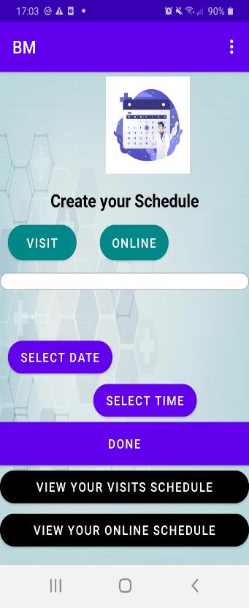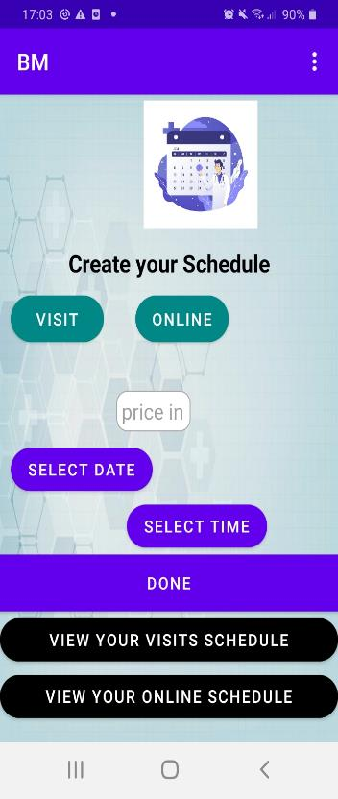

Figure ‑: Creating visit and online consultations schedules

In this activity the doctor will create both online and visit consultations schedules. If he/she clicks on visit button, a text view and 3 buttons are visible, the text view is for specifying the location of the clinic. If this text view is kept empty then we assume that the place of the visit consultation is considered as the clinic address that is specified by the doctor in the sign up page, else, clicking on this text view will direct the doctor to an activity including a Google map fragment, specifying the new place of the visit consultation on this map is similar of the process of setting the location in the signup activity.

Clicking on the button below this text view will show a date dialog to pick a date, the button below it is used in order to pick a time using a time picker like below:

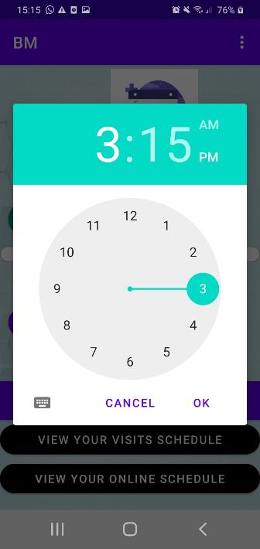

Figure ‑: Choose time

Clicking on the “done” button will save date and time to the Firebase Firestore.

Now, when the “online” button is clicked, an edit text to provide the price is visible to set the price of the online consultation, of course along with providing the date and time like the visit consultation. Clicking on the “done” button will save the date and time to the database.

When the doctor clicks on “view your visit schedules” button will launch an activity showing the days of the weeks like below:

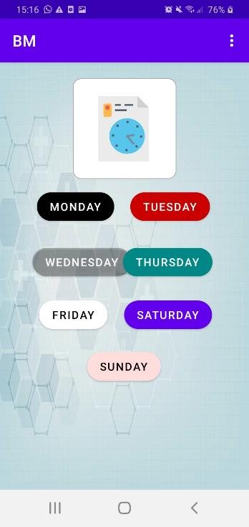

Figure ‑: Days of the week activity

The dates and times specified by the doctor for visit consultations are distributed along the days of the week, so clicking on every day of the week will show the dates, times and locations specified in this day inside a recycler view like below:

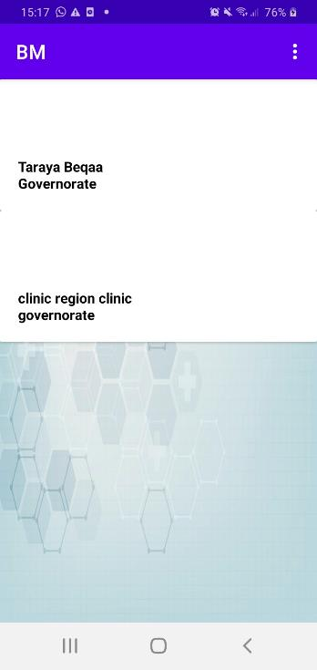

Figure ‑: Visit consultations schedule in a specified day of the week

Now when the doctor clicks on “show online consultation schedule”, same process will be repeated and the doctor can see the online consultations schedule on a specified day of the week like below:

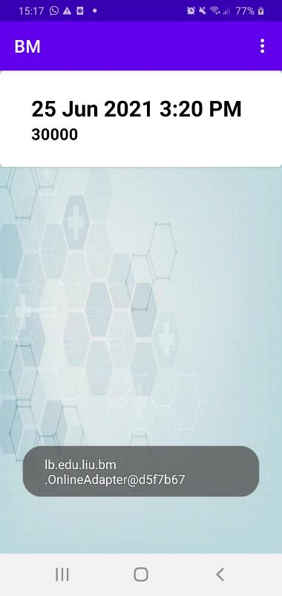

Figure ‑: Online consultations schedule on a specified day of the week

The main advantage of using this type of schedules is that the doctor will not be restricted by a weekly schedule that will be repeated every week. In this application, the doctor can change his/her schedule every day and it is more flexible. If the doctor predicts that he will be absent at any day for a given case, he/she will simply reduce his/her schedule at that day immediately.

Back to the doctor home activity, clicking on the “profile image will launch an activity containing some info about the doctor previously provided like below:

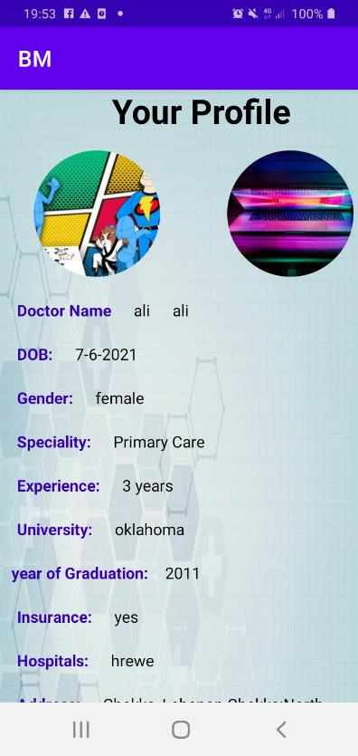 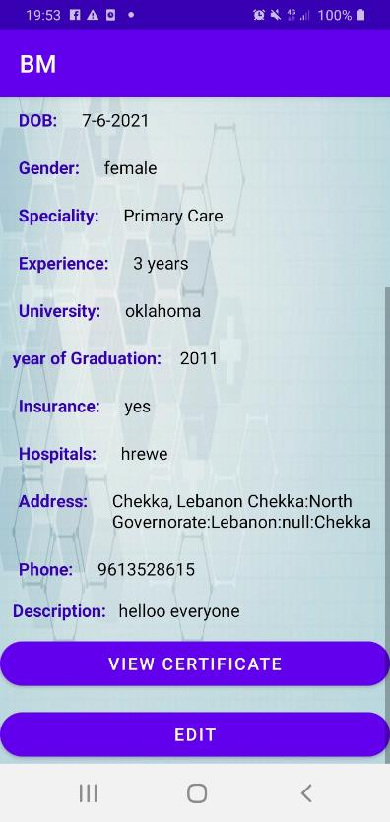

Figure ‑: Doctor's profile activity

In this activity the profile photo of the doctor and its syndicate card are retrieved from Firebase storage and set to the image views (using Glide API). Other info is retrieved from Firebase Firestore into the text fields.

When the doctor clicks on “view certificate” button, he/she will be able to view the certificate file he/she uploaded it in the register activity.

When the doctor clicks on the “Edit” button, he will be directed to an activity where he/she will be able to edit his/her profile like below:

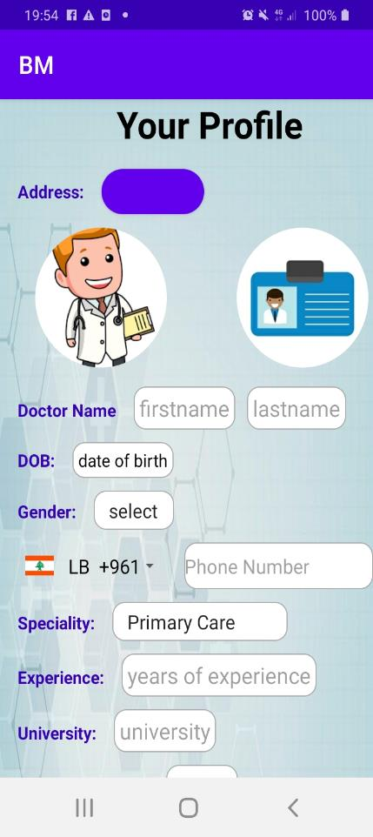 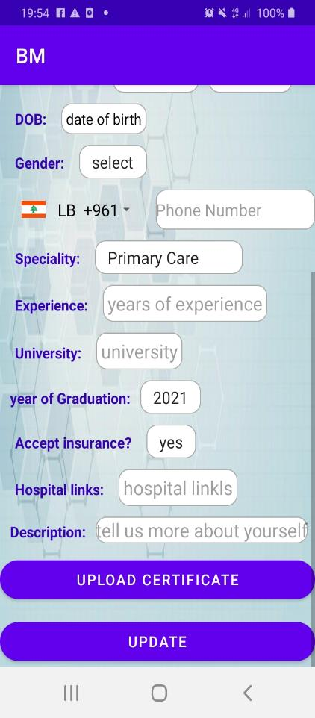

Figure ‑: The doctor edit profile activity

In this activity, the doctor is asked to re-provide all the info he/she has provided before if he wants it. Clicking on the update button will update the database with the new values.

Let’s go back to the home activity, if the doctor clicks on the appointments image, he/she will be directed to an activity to choose the type of the appointment like below:

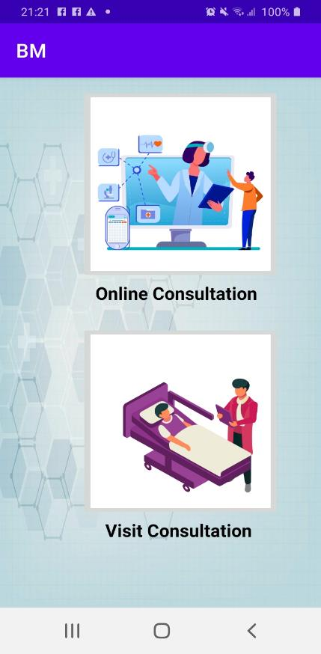

Figure ‑: Choose type of consultation

When the doctor clicks on “online consultation” image, he/she will be directed to an activity that shows the online consultation appointment in a recycler view like below:

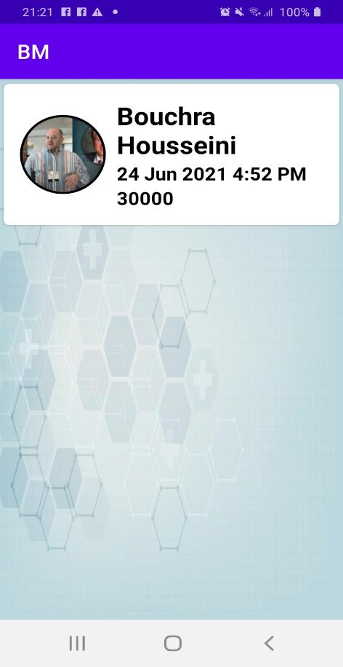

Figure ‑: Online consultation appointments

Each row inside the recycler view will show the profile image of the patient, along with his/her full name, date and time of the consultation and its price.

Clicking on any row of the recycler view will direct the doctor to an activity like below:

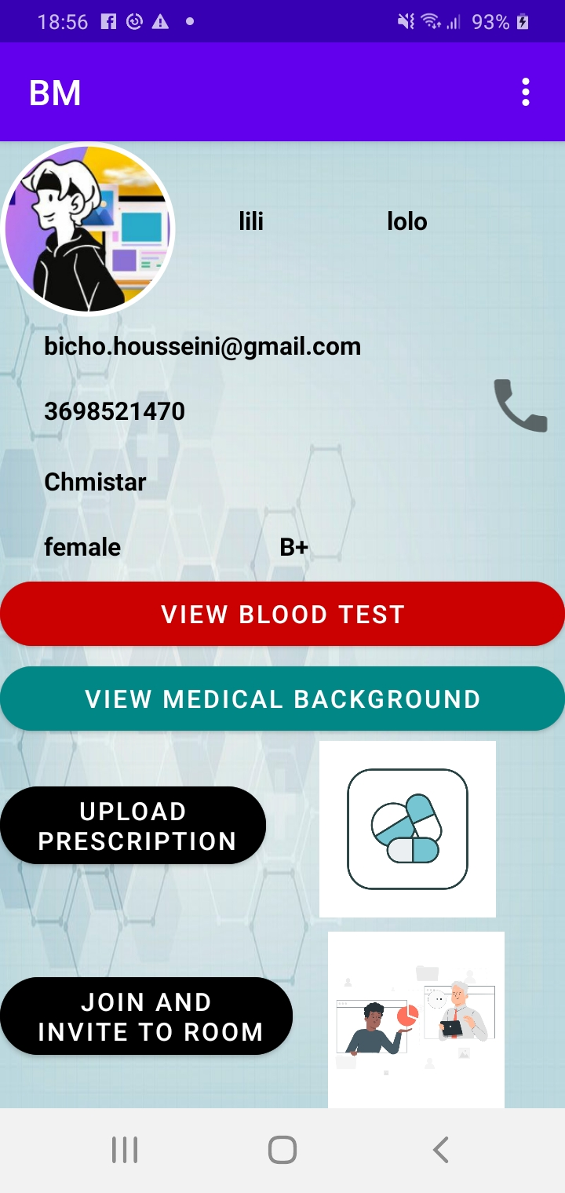

Figure ‑: Patients info

In this activity, the doctor can see some information about the patient booking for the appointment he/she clicked on. He/she can call his/her patient by clicking on the phone icon, it will perform a dial action using the phone number of the patient.

By clicking on “view blood test” button, the doctor will be able to view the blood test uploaded by the patient.

By clicking on” view medical background” button, the doctor will be able to see the medical survey filled by the patient.

By clicking on “upload prescription” button, the doctor will be able to upload an image of the prescription.

By clicking on “join and invite to room” button, the doctor will join a meet, the id of the room will be sent to the patient in order to join the meet on time. The id of the room is the unique id of the doctor in firebase followed by the date and time of the appointment.(to guarantee uniqueness of the room id), this online meeting will be realized using Jitsi API which is an API specific to online room meetings and that can be implemented on multiple platforms.

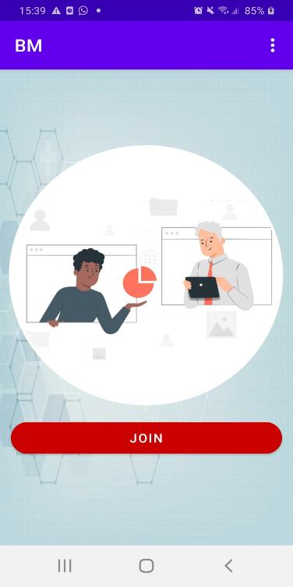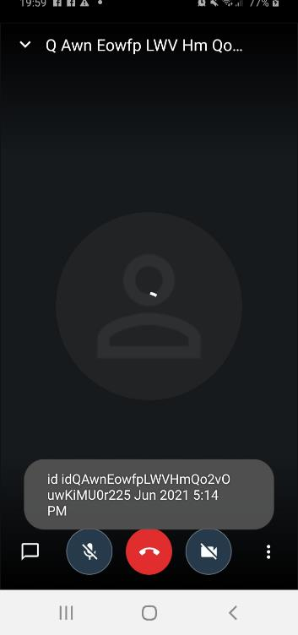

Figure ‑: Online meeting

The same process is repeated when clicking the “visit consultation image”, the doctor will be able to see visit consultation appointments in a recycler view like below:

By clicking on any row inside the recycler view, the doctor will see the same things at Figure ‎4‑33, but without the option of joining the online meeting.

Let’s go back again to the home activity, by clicking on the payment image, the doctor will be directed to an activity like below:

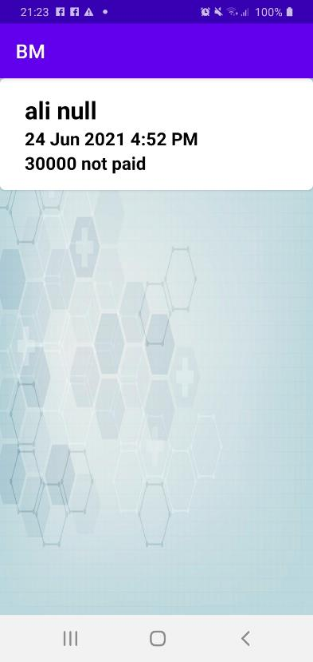

Figure ‑: Doctor's payment activity

This activity includes a recycler view that will display in each row the name of the patient, the date and time of the online consultation, its price and its status (only online consultations have payments).

If the doctor clicks on the offers image, he will be directed to an activity like below:

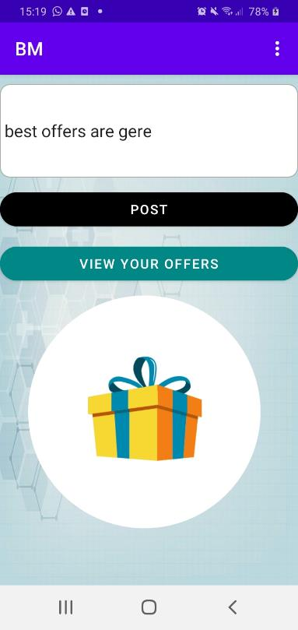

Figure ‑: Doctor's offers activity

In this activity, the doctor is asked to fill the edit text by the details of the medical offer, and then by clicking on the “post” button, the offer will be added to the database.

By clicking on the “view your offers” button, the doctor will be directed to an activity like below:

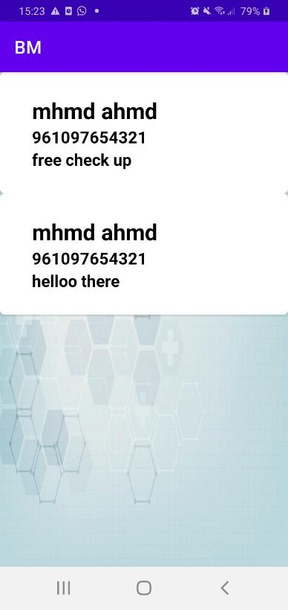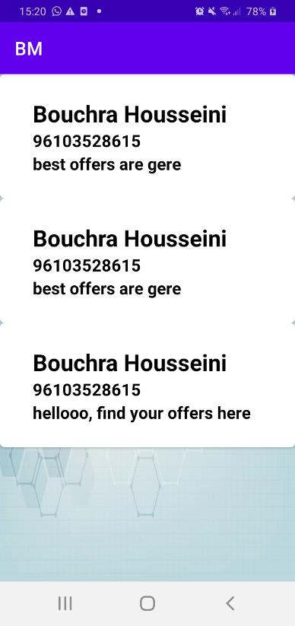

Figure ‑: Doctor's posted offers

In this activity, the recycler view displays in each row the name of the doctor, his/her phone number and his/her offer.

At the end, if the doctor clicks on “logout” button, he/she will be logged out and redirected to the login activity in order to login again when possible.

* **For patient:**

After signing up/in, the patient will be directed to an activity where he/she is asked to provide additional personal info like below:

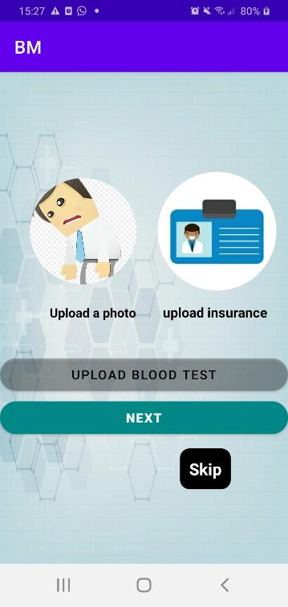

Figure ‑: Patient additional info

In this activity, by clicking on the image view associated with “upload a photo, the patient will be able to upload a photo from the internal storage, same thing for the insurance.

By clicking on the “upload blood test” button, the patient will be able to upload only a pdf file which refers to his blood test.

Clicking on the “next” button, all provided data will be added to the database but the patient has also the option to skip this activity without affecting the database and go to the next activity like below:

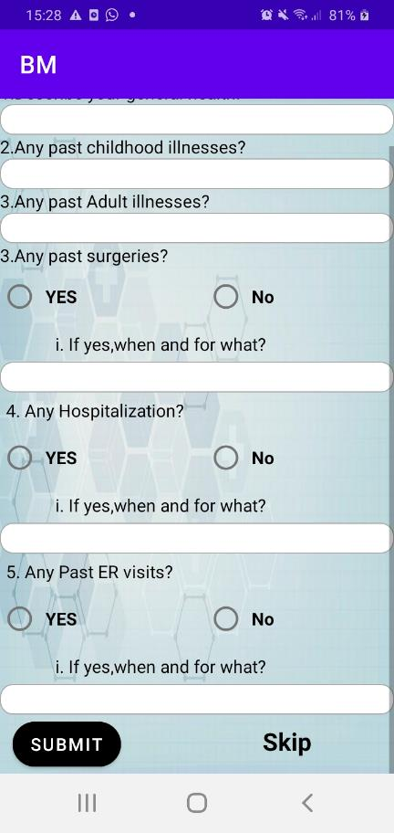

Figure ‑: Patient medical survey

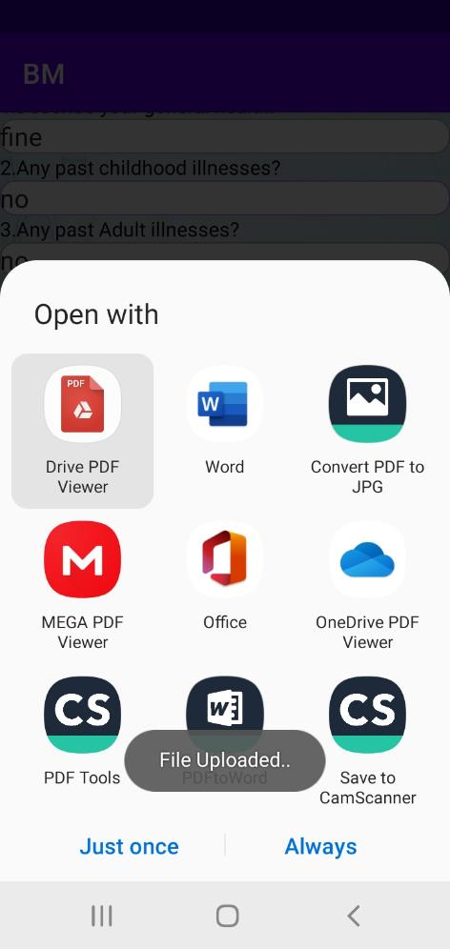

Figure ‑: XML to pdf conversion

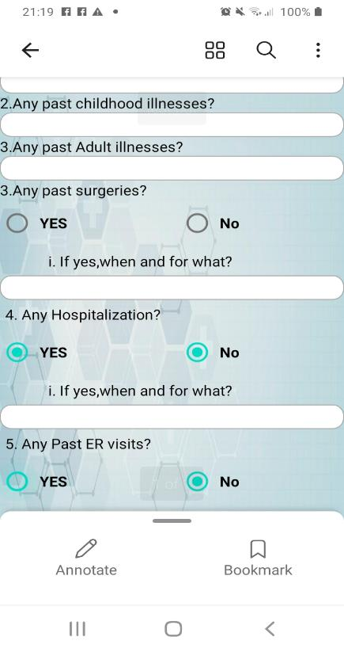

Figure ‑:PDF viewed in OnDrive pdf viewer

In this activity, the patient is asked to fill this survey which serves as a medical background that will help his/her doctor in the check up. After filling it, if the patient clicks on “submit”, the XML layout will be converting as it is to a pdf after taking a screenshot of it, and then uploaded to Firebase storage and its link will be uploaded to the database.

Also the patient has the option to skip this activity and go to the next activity which is the patient home activity presented below:

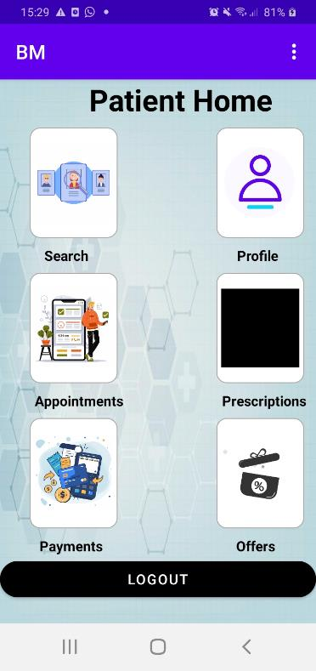

Figure ‑: Patient home activity

This is the patient home activity: if the patient clicks on the search activity, he/she will be directed to the activity below:

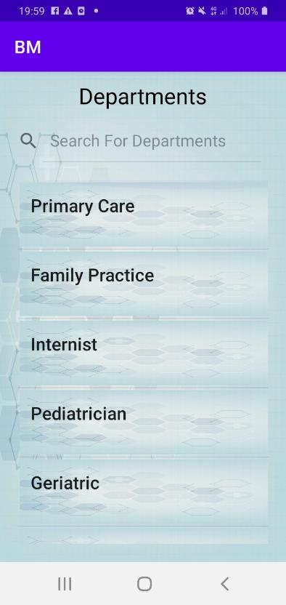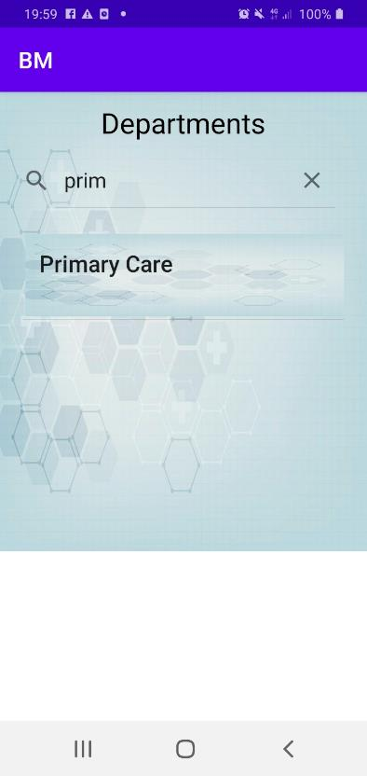

Figure ‑: Choose department

In this activity, the patient is asked to choose the specialty of the doctor he/she looks for from the above recycler view, he/she can even search for it without the need to scroll down to find it.

After clicking on a specific specialty from the recycler view, the patient will be directed to an activity like below:

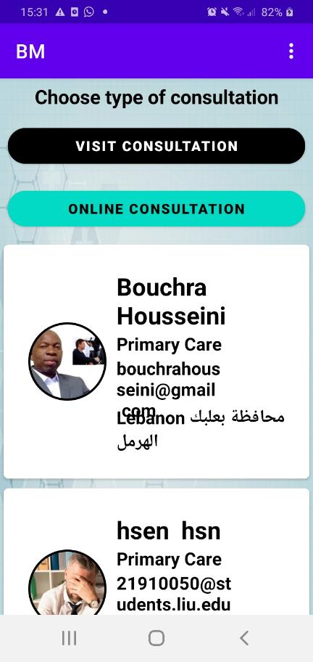

Figure ‑: Choose type of consultation

This activity displays all the available doctors of the chosen specialty inside a recycler view. Now, the patient is asked to choose the type of consultation, if he/she chose “visit consultation, he/she will be directed to the activity below:

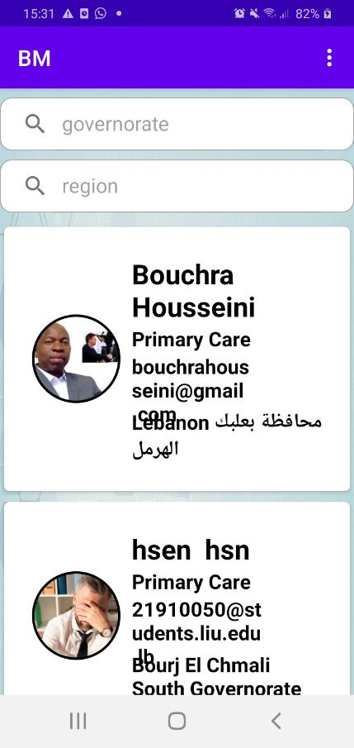

Figure ‑: Filter doctors by their addresses

In this activity, the patient can filter all the doctors with the specialty he/she choose from the recycler view using 2 search views, the first one will filter doctors by governorates, the second one will filter the doctors by their regions within these governorates.

After filtering, the patient now can choose a doctor from the filtered options, and this will direct him to the activity below:

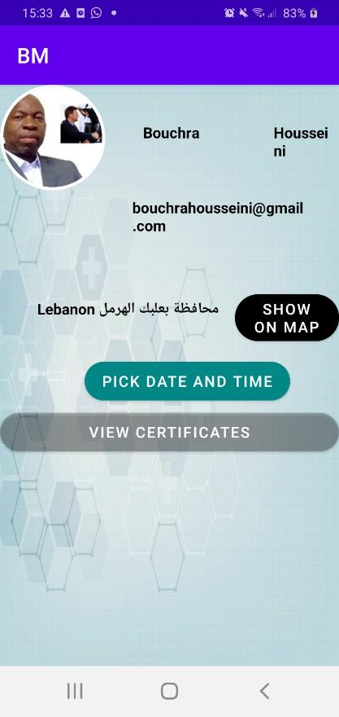

Figure ‑: Pick an appointment

In this activity, the patient will view some of the info about his/her doctor including his/her certificates using the pdfviewer API. If he/she clicks on the “show on map” button, Google maps app will be open and it will show the exact place of the doctor clinic using its coordinates from the database. The patient will be able then to see directions, compute distance and time to reach the clinic.

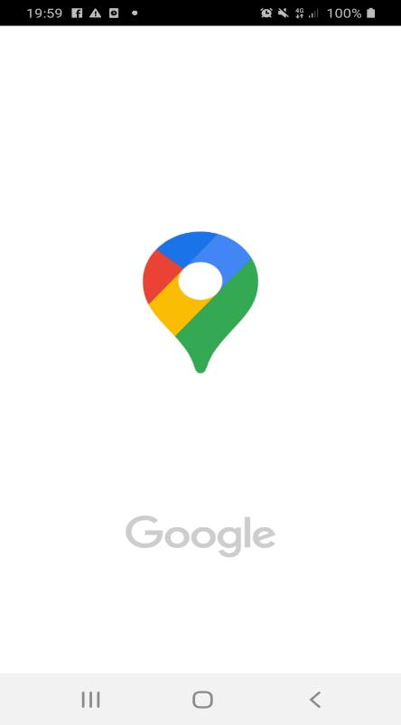

Figure ‑: Opening Google maps

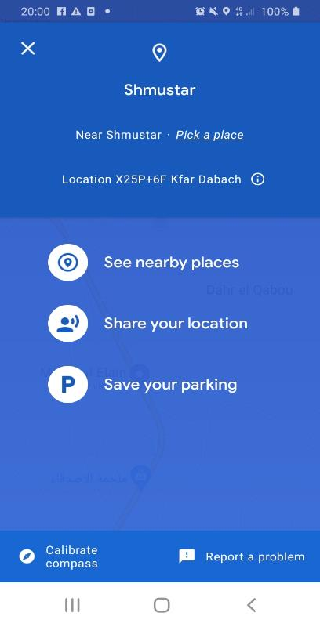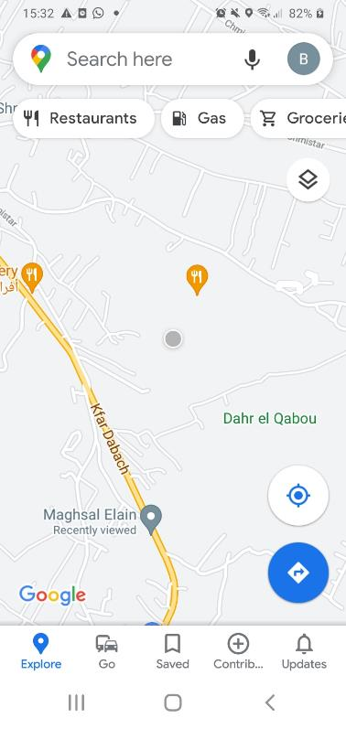

Figure ‑: Doctor's clinic location

Now, if the patient clicks on “pick date and time button”, he/she will be directed to the below activity:

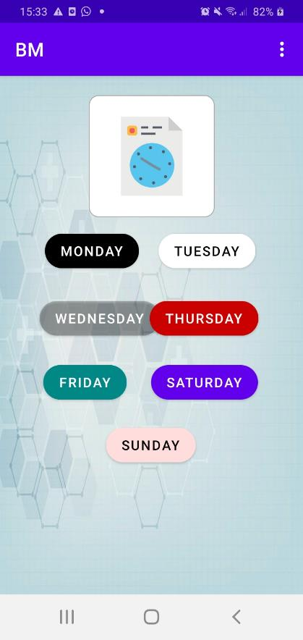

Figure ‑: Choose a day

In this activity, the patient needs to specify which day of the week suits him/her the best to book an appointment, clicking on any of these days will direct the patient to the activity below:

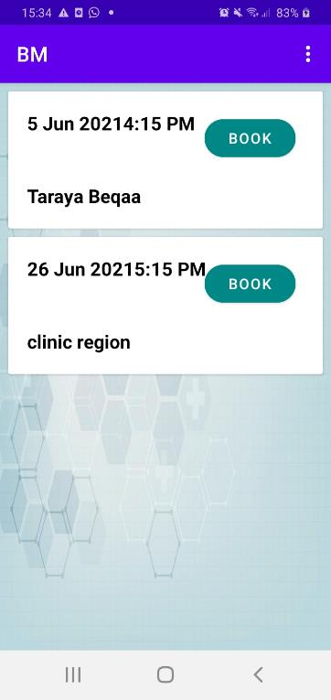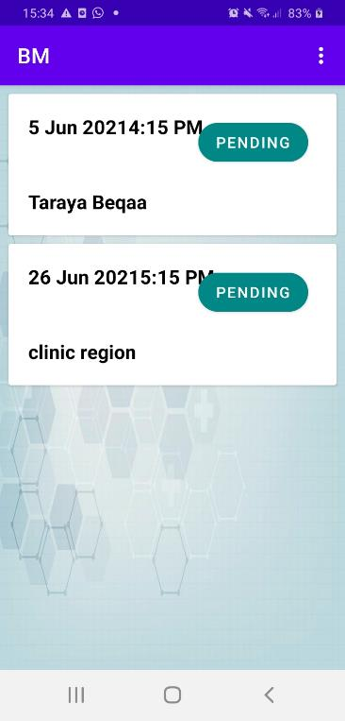

Figure ‑: Book appointment

This activity will show all the available dates and times that refer to the specified day of the week. Every row is showing the date and the time available, along with address of the clinic and a button “book”. Clicking on this button will change its text to pending and also the status of the appointment in the database from “available” to “pending” so that it will not be visible by another patient until it is declined by the doctor (pending appointments will be shown in the requests activity of the doctor and in the waiting list activity of the patient).

Same process will happen when the patient selects “online consultation” but there will be no filtering, the patient will pick a doctor from a row, then picks a date and a time like in the “visit consultation” booking process and issues a request for it.

Back to the patient’s home activity, clicking on the profile image will show the profile of the patient (similar to the doctor’s profile activity).

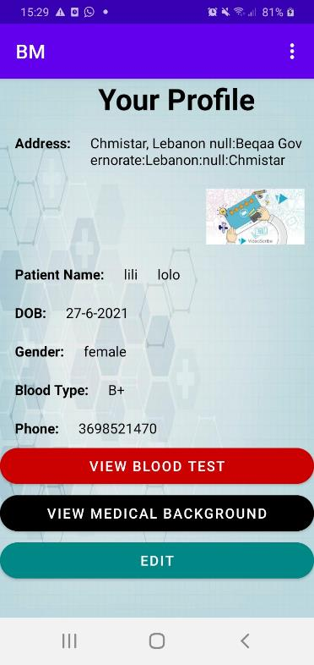

Figure ‑: Patient's profile activity

When the patient clicks on “Edit”, he/she will be directed to the activity below:

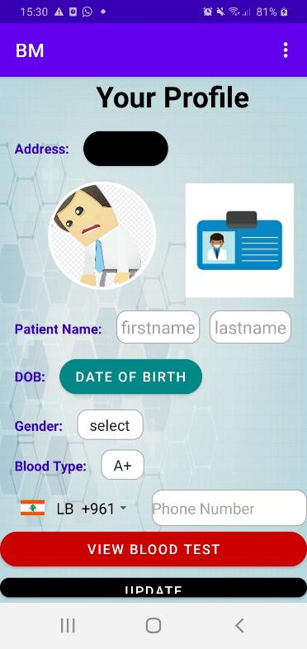

Figure ‑: Patient edit profile activity

Here, the patient can edit his profile the way the doctor did. Additionally, clicking on the “update” button will direct the patient to an activity similar to the medical survey he/she has filled before in order to update it if needed.

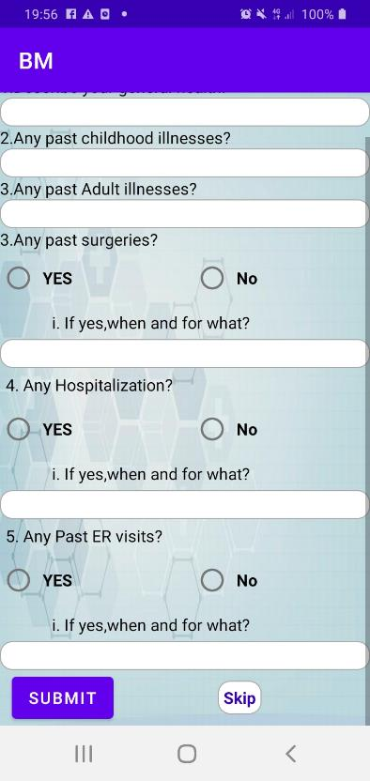

Figure ‑: Update survey

Back again to the patient home activity, clicking on the appointment image will direct the patient to the below activity:



Figure ‑: Choose the type of consultation

By clicking on the “online consultation” image, the patient will be directed to the activity below:

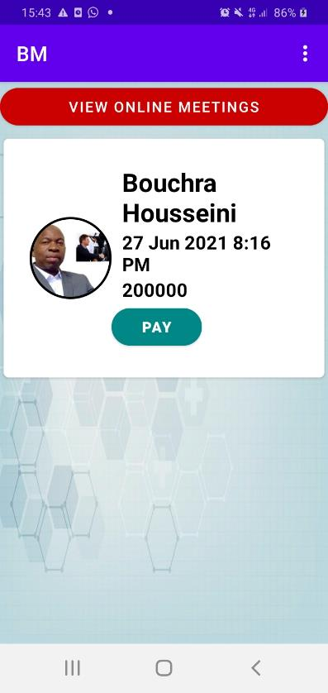

Figure ‑: Pay or join for online consultation

This activity displays the online appointments of the patient in a recycler view, in each row are shown: the image of the doctor, his/her full name, the date and time of the online consultation, its price and a button “pay”.

Clicking on this button will direct the patient to the activity below:

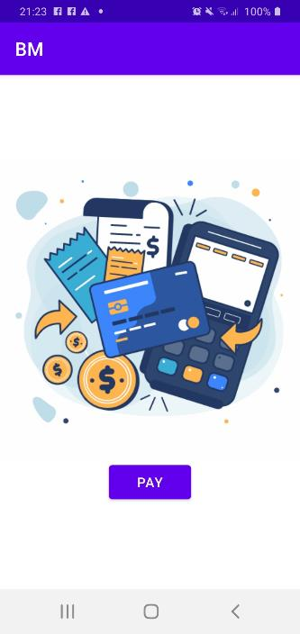

Figure ‑: Welcome to payment

Clicking on the “pay” button will direct the patient to the activity below:

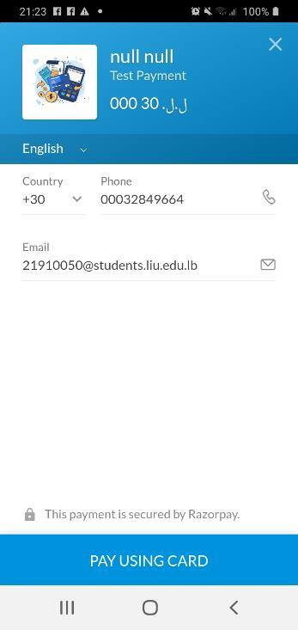

Figure ‑: Razorpay payment 1

This is a Razorpay activity, where the phone number, the email address, the name and the amount to be paid are sent to it by the database.

When the patient clicks the “pay using card” button, he/she will be directed to the following activities:

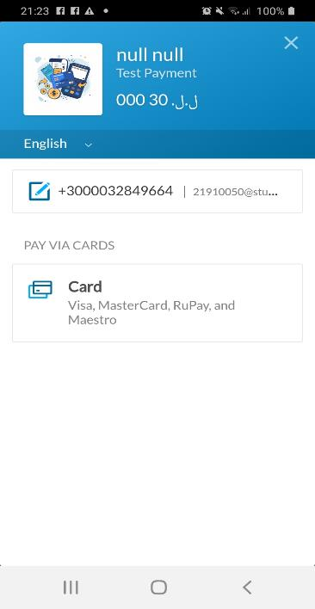

Figure ‑: Razorpay payment 2

In this activity, when the patient clicks on “Card” the following activity is launched:

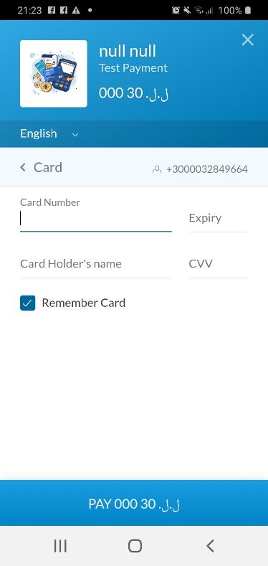

Figure ‑: Razorpay payment 3

In this activity, the patient is asked to enter his/her card number, expiry date, his/her name and the CVV. Then when he/she clicks on the bottom button, the payment will be achieved (of course after checking the existence of enough balance).

Back to this activity:



Figure ‑: Patient online appointments

When the patient clicks on the “view online meetings” button, he/she will be directed to the activity below:

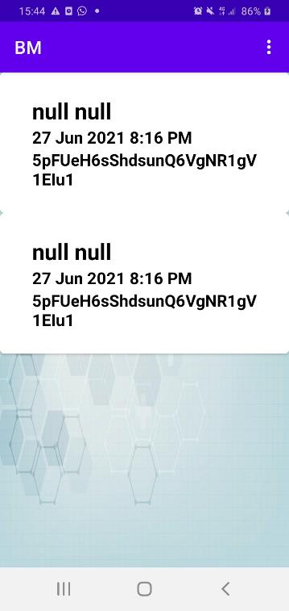

Figure ‑: Meetings details

This activity displays the ids of the online room meetings with every doctor inside a recycler view (these rows will not be displayed or available for the patient until the doctor joins the meeting first), so by clicking on the row, the patient will join the room with his doctor like below:

The meeting is able to be recorded; the doctor or the patient can invite people to the meeting via social media…

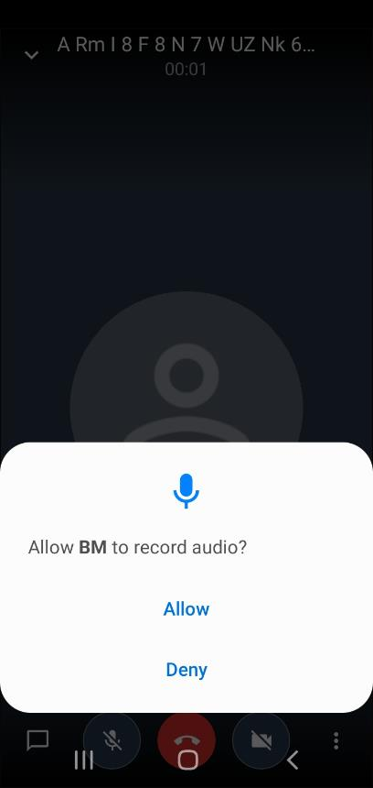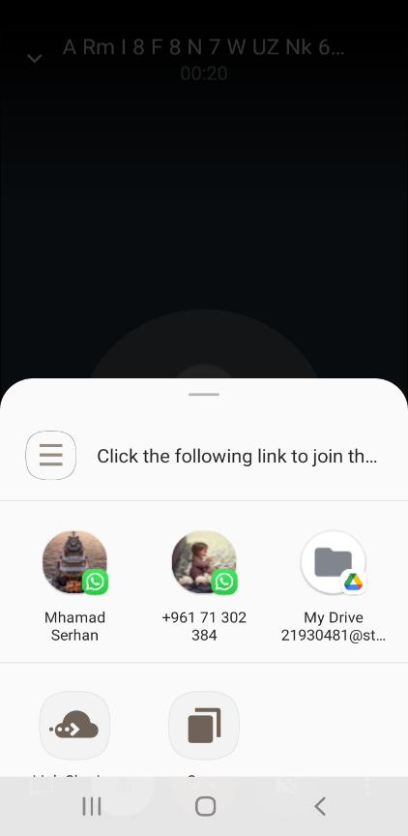

Figure ‑: Online meeting

Again, back to the patient home activity, clicking on the prescription image will direct the patient to the activity below:

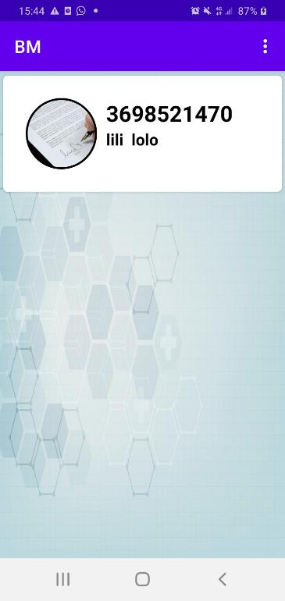

Figure ‑: The patient prescriptions activity

This activity includes the prescriptions uploaded by the doctor to this patient, clicking on the prescription image will zoom it in.

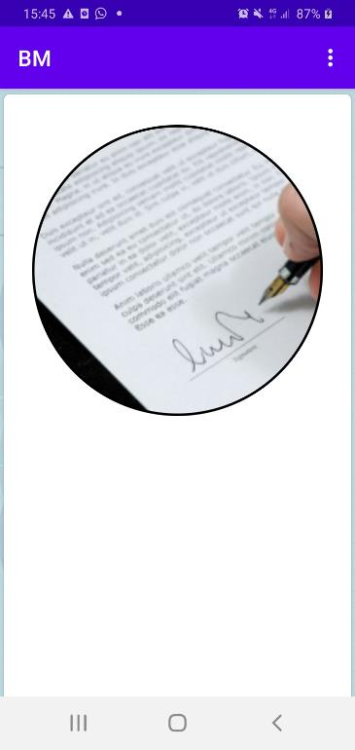

Figure ‑: Prescription zoomed in

Let’s go back one more time to the home activity, clicking on the payment image will display the payments of the patient in a recycler view along with the name of the doctor, the date and the time of the online consultation (only online consultations have payments), its price and its status like below:



Figure ‑: The patient payments activity

If the patient clicks on the offers image, he/she will be directed to the activity below:

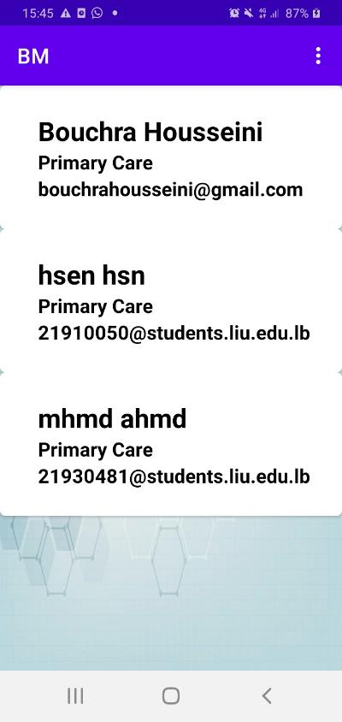

Figure ‑: Doctors list

This activity displays the list of the registered doctors, when the patient clicks on any row; he/she will be directed to an activity showing the offers posted by the chosen doctor the way they were shown in the doctor’s “see offers” activity.

In the home activity, specifically in the toolbar, if the patient clicks on the waiting list item, he/she will be directed to an activity like below:

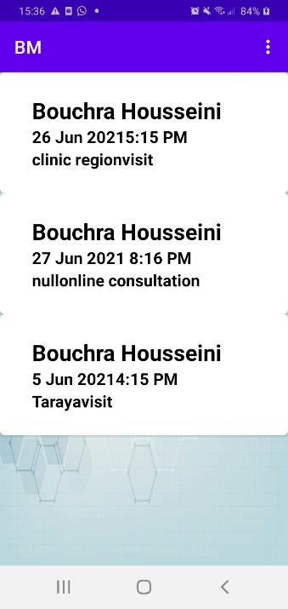

Figure ‑: The patient waiting list

In this activity, the patient will see all the pending appointments that were not accepted or declined by the doctor, every row shows the full name of the doctor, the date and time of the consultation, its place and its type( visit or online).

And finally, when the patient clicks on the logout button, he/she will be logged out and redirected to the login activity in order to login again when needed.

## Test Cases and Acceptance Criteria:

This application includes multiple test cases; we will list the most important 2 of them.

1. **Doctors filtering by location:**

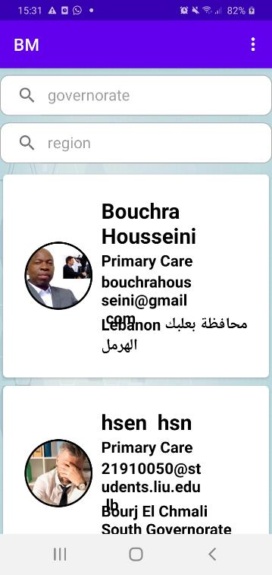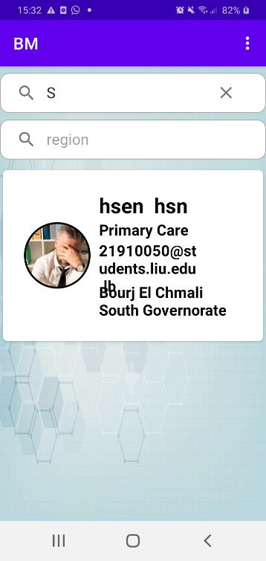

Figure ‑: Doctors filtering by location

In this activity, the doctors with the medical department chosen by the patient are listed, and as we can see we can filter them by governorate and region.

In the first image we have all the doctors listed, but in the second one, when typing “s” in the search view, only the doctor with south governorate is shown and the other ones disappear.

1. **medical departments filtering:**



Figure ‑: Medical departments filtering

As we can see, in the image at the left, all the medical departments are listed inside the recycler view, and in the image at the right, when the patient types “prim”, only the “primary care” specialty is shown. Searching is performed ignoring the case of the typed query text.

## Conclusion

This chapter has detailed the functions of most of the features implemented in this mobile application. Starting by the authentication processes including, email/password, phone number and Google authentication, moving to explaining how multiple Medias can be uploaded to Firebase storage.

We discussed how we can use date and time pickers to create schedules and distribute these schedules on the days of the week; we detailed how the adapters display the data retrieved from the Firebase Firestore.

In addition to that, we learned how to use search views in order to filter the recycler views.

Also we introduced the concept of using Google map fragments inside the mobile application using Google maps API, and how to launch Google maps to a specific location.

We introduced the concept of using pdf viewer API in order to display the pdf files uploaded by the users.

We presented how we can perform phone calls, online video meetings, online payment using multiple different APIs like “Jitsi”, “Razorpay”…..

At the end, the completion of this mobile application took a lot of efforts, but it deserves it.

# Conclusion and Future Work

## Conclusion

The road to building the "MB-Care Plus" program was neither easy or straightforward. We made several errors through the various stages of ideation, design, implementation, and testing, but we were able to correct them and learn from them. All of the mistakes and roadblocks we encountered simply grew our experience and expertise of our field of work.

However, the completed application makes us very proud of what we have accomplished, considering the limited financial resources that we have at our hand, in contrast to the resources of the developers of the popular e-booking appointments on the market.

We went on this lengthy trip, filled with difficulties and obstacles, with courage, and this project was a major milestone in our trip. Yet we are more than ever eager to go on this journey in order to succeed in the improvement of mankind and ourselves.

## Future Work

Multiple features could be added to this application in order to make it more enhanced and more competitive.

There is a possibility to use machine learning in order to examine for example the skin of the patient (detecting acne) or tooth decay. These results can serve as preliminary results for the doctor.

We can build an application between doctors and pharmacies, to manage prescriptions containing specific patients IDs in order to insure the will not use the same prescription the same drugs more than one time from different pharmacy and exceeds the dose recommended by his/her doctor (especially nerve drugs).

We can also integrate the ability of the delivery of the drugs in the prescriptions to patient’s house.

Finally, and as Google maps directions API is not for free, it could be more efficient to integrate it in our application in the future.

REFERENCES

|  |  |
| --- | --- |
| [1] | O. s. b. c. d. World Health Organization's Global Health Workforce Statistics, "The World Bank," 2018. [Online]. Available: https://data.worldbank.org/indicator/SH.MED.PHYS.ZS. [Accessed 8 3 2021]. |
| [2] | M. &. Garritano, "TELLEMEDICINE WITH HUMANA," 13 09 2018. [Online]. Available: https://www.morrisgarritano.com/files/Benefits%20Resource%20Library/Carrier%20Reference%20Materials/Humana/Humana%20Telemedicine.pdf. [Accessed 14 03 2021]. |
| [3] | "Doctor Appointment App Development: Steps, Monetization Methods, Security Tips," cadabra, 27 August 2020. [Online]. Available: https://cadabra.studio/blog/doctor-appointment-app-development-guide#5. [Accessed 27 3 2021]. |
| [4] | S. Heath, "Patient Engagement Hit," 03 07 2018. [Online]. Available: https://patientengagementhit.com/news/top-challenges-impacting-patient-access-to-healthcare. [Accessed 12 03 2021]. |
| [5] | "PlushCare," [Online]. Available: https://plushcare.com/how-it-works/. [Accessed 28 march 2021]. |
| [6] | H. Vdovychenko, "How to develop healthcare app for booking doctor appointments," 21 july 2020. [Online]. Available: https://apiko.com/blog/doctor-booking-app/#:~:text=ZocDoc%20is%20another%20popular%20app,Online%20appointments. [Accessed 27 3 2021]. |
| [7] | "KRY.se," KRY, [Online]. Available: https://www.kry.se/en/how-it-works/. [Accessed 27 March 2021]. |
| [8] | O. Kholodenko, "THE SIMPLE GUIDE ON DOCTOR APPOINTMENTS APPS," 12 january 2021. [Online]. Available: https://codeit.us/blog/doctor-appointment-app. [Accessed 27 march 2021]. |
| [9] | T. Jewell, "The Best Telemedicine Apps of 2020," 11 August 2020. [Online]. Available: https://www.healthline.com/health/best-telemedicine-iphone-android-apps#doctor-on-demand. [Accessed 27 March 2021]. |
| [10] | L. Tung, "ZDNet," 29 May 2020. [Online]. Available: https://www.zdnet.com/article/googles-android-studio-4-0-is-out-motion-editor-build-analyzer-java-8-language-apis/. [Accessed 13 5 2021]. |
| [11] | C. Esplin, "What Is Firebase?," 24 October 2016. [Online]. Available: https://howtofirebase.com/what-is-firebase-fcb8614ba442. [Accessed 13 5 2021]. |
| [12] | N. Kotia, "Guide to Mobile App Architecture: iOS and Android," 21 11 2019. [Online]. Available: https://www.konstantinfo.com/blog/mobile-app-architecture/. [Accessed 13 5 2021]. |
| [13] | tutorialspoint, "UML - Class Diagram," [Online]. Available: https://www.tutorialspoint.com/uml/uml_class_diagram.htm#:~:text=Class%20diagram%20is%20a%20static%20diagram.%20It%20represents,for%20constructing%20executable%20code%20of%20the%20software%20application.. [Accessed 14 5 2021]. |
| [14] | v. paradigm, "What is Sequence Diagram?," [Online]. Available: https://www.visual-paradigm.com/guide/uml-unified-modeling-language/what-is-sequence-diagram/#:~:text=Sequence%20Diagram%20is%20an%20interaction%20diagram%20that%20details,when%20they%20take%20part%20in%20the%20message%20sequence.. [Accessed 15 5 2021]. |
| [15] | v. paradigm, "All You Need to Know about State Diagrams," [Online]. Available: https://www.visual-paradigm.com/guide/uml-unified-modeling-language/about-state-diagrams/. [Accessed 15 5 2021]. |
| [16] | A. Dearmer, "Firebase vs. MySQL: Battle of the Databases," 01 December 2020. [Online]. Available: https://www.xplenty.com/blog/firebase-vs-mysql/. [Accessed 13 5 2021]. |
| [17] | j. community, "Jitsi," [Online]. Available: https://jitsi.org/about/. [Accessed 6 6 2021]. |
| [18] | "Craft," [Online]. Available: https://craft.co/razorpay. [Accessed 6 6 2021]. |